SPORT LITERATURE ASSOCIATION
41st Annual Conference
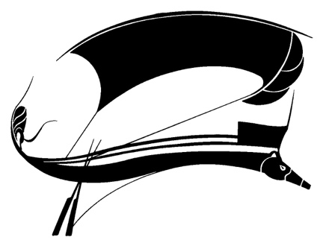
Orono Maine
June 19-22, 2024
Host: Bruce Pratt
Program Chair: Matt Tettleton
Name ______________________________________________
Email ______________________________________________
Phone/Text ______________________________________________
Affiliation University _____________________________________
Independent Scholar _____________________________
Graduate Student _______________________________
Are you presenting? _____________________________
Registration $275.00 (includes breakfast, lunch, banquet, Tshirt) ______
Paid by enclosed check made out to The University of Maine and sent to Bruce Pratt, 579 Town House Road, Swanville, Maine 04915
If preferring to pay by credit or debit card through PayPal or Venmo, please email Bruce for the needed information.
** If you are an international member and need to pay by wire transfer or ACH, please contact joyced1001@cs.com for information.
T-shirt size S ___ M ___ L___ XL ___ 2X ____
____Xtra fee for lobster (Marketprice Payable at the Banquet)
Housing (paid to hotel directly)
Black Bear $165.00/night Call 207-866-7120 Mention conference
Other options booked individually (refer to previous email)

Arriving Date and Time _______ at ________________________(airport)
Require transportation Y ___ N ___
Membership
Regular $70.00
Retirees and Students $30.00
Membership must be current to present or attend
Please send check (with copy of this form) to
SLA, Box 70270 ETSU, Johnson City TN 37614
If you prefer to pay membership electronically through PayPal, please contact JoyceD1001@cs.com
Dorm
Double $30.00/night Single $65.00/night

If staying in dorm, please return this completed form to Joyced1001@cs.com with check made out to SLA or contact joyced1001@cs.com if preferring PayPal
Double $30.00/night________
Single $65.00/night_________
Number of Nights___________
Dates _____________________
Roommate Preference __________________________________
Please return separate copy of form to both Bruce Pratt (obdriveway@aol.com) and to Joyce Duncan (joyced1001@cs.com)

