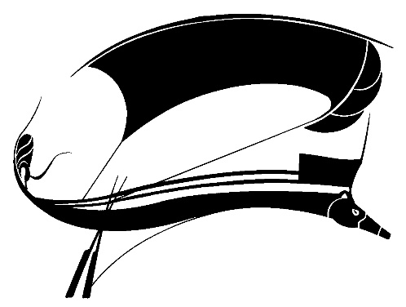
CALL FOR PAPERS
SPORT LITERATURE ASSOCIATION
ANNUAL CONFERENCE XLI

Host: Bruce Pratt
Program Chair: Matt Tettleton
Abstract Deadline: March 31, 2024
Conference Dates: June 19-22, 2024

The forty-first annual conference of the Sport Literature Association will be held at the University of Maine in Orono, Maine, from June 19-22, 2024.

The Program Committee of the Sport Literature Association (SLA) invites proposals for individual papers and/or complete panels related to the literature of sport. Scholarly and critical submissions for the conference should follow general guidelines set forth in the association’s publication, Aethlon: The Journal of Sport Literature, which “celebrate[s] the intersection of literature with the world of play, games, and sport.” Submissions should address treatments of sport in texts or textual media (print, film, performance, digital or other media). We invite work on sport literature (fiction, nonfiction, poetry, drama, or film) or on the rhetoric of sport. Cultural studies approaches to sport texts are welcome. We also encourage sessions featuring presenters’ original fiction, creative nonfiction, and poetry. Original prose and poetry may be presented in a regular panel or during an evening readings session. Please note that the purpose of SLA is to forward the appreciation and knowledge of the literature surrounding sport and that all presentations should have a connection to literature; program selections will be made accordingly.

As an international, diverse, and inclusive association, SLA is committed to equity and equality. We foster an environment in which all people deserve and are given respect. To this end, our meetings, conferences, and publications attempt to use appropriate language that reflects this commitment.

Submitting your abstracts or presentation proposals
Those interested in presenting should send abstracts of individual papers or original work or proposals for complete panels by March 31, 2024 to the Program Chair, Matt Tettleton, at sportlit2024@gmail.com and Host Bruce Pratt at obdriveway@aol.com.
Submissions should include the presenter’s name, phone number, postal and email addresses, paper title, and a 250-word abstract. Abstracts, published in post-conference proceedings, will be included only for authors who attend the conference and present their material. Indicate the type of presentation as critical study, fiction, creative nonfiction, or poetry. Please indicate any requests for technology (Power Point, audio/video, etc.). Individual proposals may, but are not required to, include suggestions for possible panel placement. Presentations must be in English and not exceed 20 minutes.

Membership
All presenters and conference attendees must be current members of the Sport Literature Association. Contact Joyce Duncan at joyced1001@cs.com for further information.

Lyle Olsen Graduate Student Essay Prize
SLA welcomes papers from emerging and early career scholars and graduate students. Small travel stipends may be available for the latter. Graduate students also may submit essays for the Lyle Olsen Graduate Student Essay Prize. Details for the contest will be included in a separate announcement to follow.

