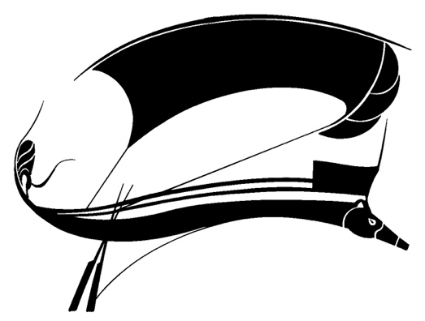
CALL FOR PAPERS
LYLE OLSEN GRADUATE STUDENT ESSAY PRIZE
SPORT LITERATURE ASSOCIATION CONFERENCE

Deadline: April 13, 2024

The Program Committee for the Sport Literature Association invites submission of research papers to be considered for the annual Lyle Olsen Graduate Student Essay Prize. The winner will receive a year’s membership in the Sport Literature Association and a small cash stipend, present the paper at the Association conference, and have the paper published in Aethlon: The Journal of Sport Literature. Students currently enrolled in a graduate program in any field of study are eligible and encouraged to submit a paper. Small travel stipends for the conference may also be available.

Scholarly and critical submissions for the Lyle Olsen Graduate Student Essay Contest should follow general guidelines set forth in the association’s publication, Aethlon: The Journal of Sport Literature, which “celebrate[s] the intersection of literature with the world of play, games, and sport.” Submissions “should address treatments of sport in texts or textual media (print, film, performance, digital or other media).” We invite essays on sport literature (fiction, nonfiction, poetry, drama, or film), on the rhetoric of sport, or on cultural-studies approaches to sport texts.

Those interested in being considered for the prize should send a completed paper by April 13, 2024, to the contest chair, Mark D. Noe, at markdnoe@comcast.net. Submissions must include the author’s name, phone number, postal and email addresses, paper title, and a 250-word abstract.

