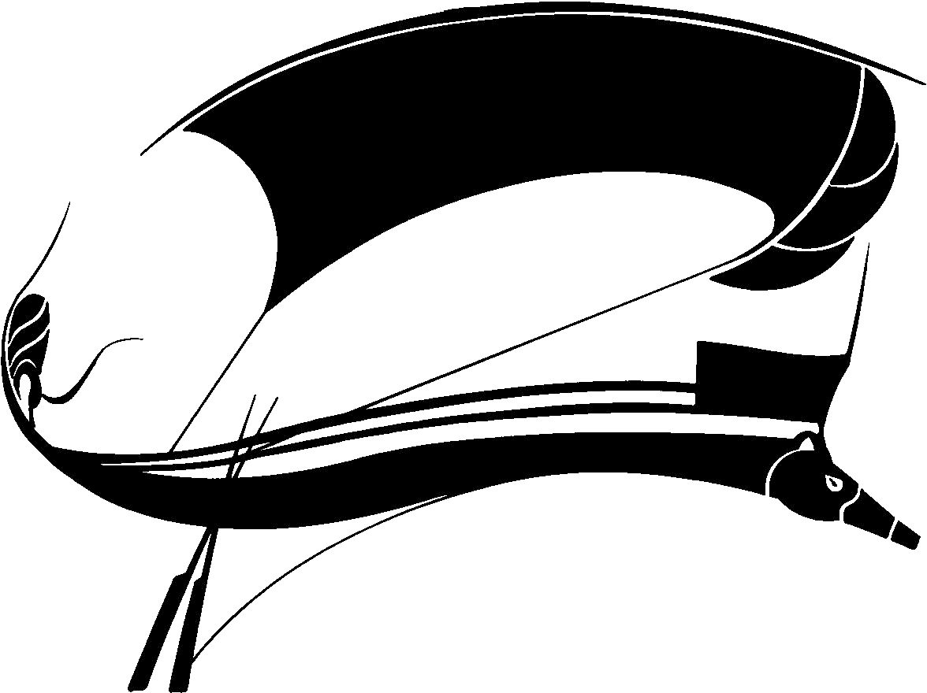

# SPORT LITERATURE ASSOCIATION ANNUAL CONFERENCE XXXIX

**Call for Papers**

**Host:** Jamie Dopp

**Program Chair:** Angie Abdou

**Abstract Deadline:** April 1, 2022

**Conference dates: Wednesday June 15 – Saturday June 18**

# Call for papers

The thirty-ninth annual conference of the Sport Literature Association will be conducted June 15-18, 2022. COVID-willing, there will be an in-person conference in Victoria, British Columbia, with an accompanying virtual conference by Zoom. If required by circumstance, the conference will be held virtually during the same period.

Whatever the exact format (to be announced as soon as possible), the Sport Literature Association is excited to facilitate another conference that is open and accessible to scholars of sport literature from around the world and at any stage in their academic career.

The Program Committee of the Sport Literature Association (SLA) invites proposals for individual papers or complete panels related to the literature of sport. Scholarly and critical submissions for the conference should follow general guidelines set forth in the association's publication, *Aethlon: The Journal of Sport Literature*, which “celebrate[s] the intersection of literature with the world of play, games, and sport.”

All abstract submissions should address treatments of sport in texts or textual media (print, film, performance, digital or other media). We invite work on sport literature (fiction, nonfiction, poetry, drama, or film) or on the rhetoric of sport. Cultural studies and sociological approaches to sport texts are welcome. We also encourage sessions featuring presenters’ original fiction, creative nonfiction, and poetry.

As an international, diverse, and inclusive association, SLA is committed to equity and equality. We foster an environment in which all people deserve and are given respect. To this end, our meetings, conferences, and publications attempt to use appropriate language that reflects this commitment.

# Membership

All presenters and conference attendees must be current members of the Sport Literature Association. For information on membership, visit our website: https://sportliteratureassociation.com/membership/

To renew or become a member of the SLA, please contact Dr. Joyce Duncan at [joyced1001@cs.com](mailto:joyced1001@cs.com)

# Presentation formats:

**Traditional Presentation:** 20 minutes.

**Creative Presentation (**Fiction, poetry, creative non-fiction reading/performance): 20 minutes.

**Panel discussions:** 60 minutes. Scholars wishing to suggest a panel discussion must submit the panel theme and suggested structure for the panel as part of their abstract, as well as include the names of those wishing to be part of the panel.

# Alternative Presentation Options for 2022 VirtualConference:

Whether there is an in person gather in 2022 or not, a virtual portion of the conference will be held by Zoom to allow for presentations by members from anywhere in the world. New members who want an introduction to the SLA but who cannot attend in person are especially encouraged to attend and / or participate by Zoom.

Please indicate on your proposal if you are likely to prefer presenting in-person or by Zoom. This is, at this stage, only for planning purposes. The exact distribution of in-person and virtual sessions will be determined once circumstances become clear enough to do so.

# Submitting your abstracts or presentation proposals:

Those interested in presenting should send abstracts of individual papers or original work or proposals for complete panels by **April 1, 2022** to the Program Chair, **Angie Abdou** at [*aabdou@athabascau.ca*](mailto:aabdou@athabascau.ca)and Host **Jamie Dopp** at [*jdopp@uvic.ca*](mailto:jdopp@uvic.ca)

Submissions must include presenter’s name, phone number, postal and email addresses, paper title, and a 250-word abstract that also indicates the presentation format.

*Please note the committee reserves the right to request completed papers if it is deemed necessary to do so.*

*Abstracts will be compiled and published online on the Association listserv, Arete. Only those papers presented LIVE or through another conference medium will be published.*

# Lyle Olsen Graduate Student Essay Contest.

SLA also welcomes and encourages papers from emerging and early career scholars and graduate students, particularly via entering the Lyle Olsen Graduate Student Essay Contest.

Essays entered in the contest must pertain, in some significant way, to the literature of sport. The winner will receive a small stipend, publication in *Aethlon*, a year’s membership in the association, and an invitation to present the work during the conference.

Submit your essay (or any questions you have about the contest) to **Dr. Mark Noe at** [**marknoe@comcast.net**](mailto:marknoe@comcast.net)

**Deadline for the Lyle Olsen Graduate Student Essay Contest: April 15, 2022**