SPORT LITERATURE ASSOCIATION
37th Annual Conference
Virtual Edition
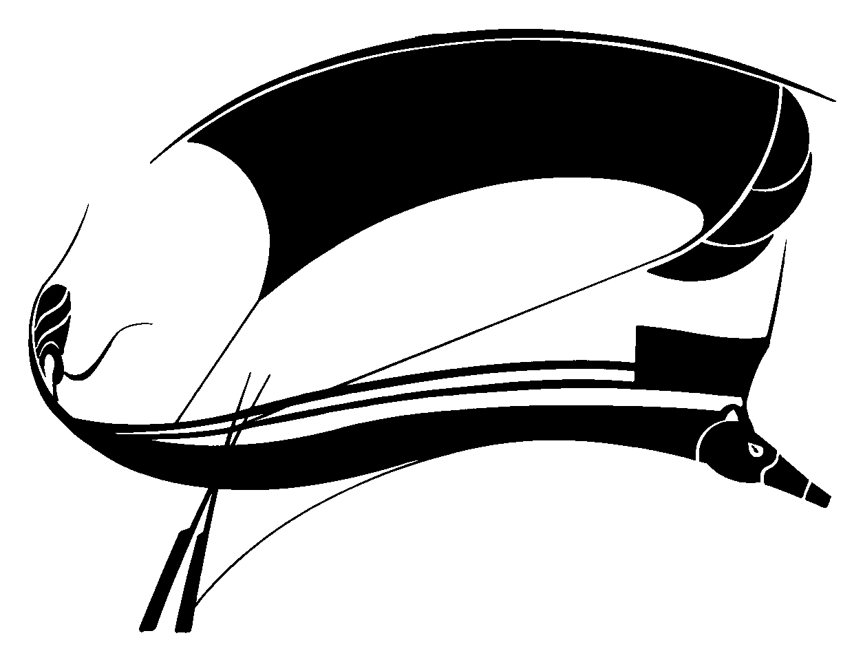
June 18-20, 2020
Host: Scott Peterson
Program Chair: Bruce Pratt
ZOOM Facilitator: Jeremy Larance

Thursday, June 18, 2020

8:00 AM Welcome
Host Scott Peterson, University of Missouri St. Louis.
SLA President Fred Mason, University of New Brunswick.

Session One: Across the Ponds 1

8:10 In not being ‘One of the Lads : An examination of the role of the female fan in “Fever Pitch.”
Kasey Symonds, Swinburne University of Technology (ksymons@swin.edu.au), and Lee McGowan, Queensland University of Technology (lee.mcgowan@qut.edu.au)

8:35 Drawing of an effort, line as link between arts and sports.
Julien Feyt, PhD Candidate, Universite Jean Monnet (julien.feyt@univ-st-etienne.fr)

8:55 Q&A

9:00 Break

Session 2: Across the Ponds 2 and The Bay of Fundy

9:15 Reconsidering Native American sporting lore and cinema (1951-2018).
Thomas Bauer, The University of Limoges (Bauer.thomas@orange.fr), and Maxence Le Conte, PhD candidate University of Texas at Austin (mpl642@utexas.edu)

9:40 American Poverty and Social Rejection in Craig Gillespie’s “I, Tonya.”
Paulina Korzeniewska-Nowakowska, Academic, poet, translator, and independent scholar (paulinakorzeniewska@gmail.com)

10:00 The Fiction of Ultrarunning.
Fred Mason, The University of New Brunswick (fmason@unb.ca)
10:20 Q&A

10:25 Break

Session 3: Fiction and Poetry

10:40 Sports Page: Excerpts from a New Poetry Collection.
Ken Waldman, independent poet and musician (ken@kenwaldman.com)

11:00 From a novel in progress about the 1922 World Series.
Scott Peterson, University of Missouri St. Louis (sdpeterson1890@gmail.com)

11: 20 Short fiction reading, “My Mother Met John Lennon.”
Robert Wallace, Creative Writer (bwallace@nc.rr.com)

11:40 Poetry Reading
Ron Smith, St. Christopher’s School (SMITHJRON@aol.com)

12:00 Q&A and End of Session

Friday, June 19, 2020

Session Four: Baseball

1:00 PM Announcements (Joyce Duncan, in lieu of business meeting)

1:05 The Celluloid Economics of John Sayle’s “Eight Men Out.”
Richard Black, Northwestern Missouri State University (RBLACK@nwmissouri.edu)

1:25 Percival Leary and Roy Hobbs: A Couple of Naturals.
Jaime Dopp, The University of Victoria (jdopp@uvic.ca)

1:45 Fifty Years of Dazzling, Dizzying Threads: Anniversary of Pittsburgh Pirates Debuting Double Knits.
Ken Moon, Iowa Western Community College (kmoon@iwcc.edu)

1:05-1:10 Q&A

1:10 Break

Session Five: Potpourri 1
1:25: The Wrong Jimenez: Baseball Fiction
Scott Palmieri, Johnson and Wales University (spalmieri@jwu.edu)

1:40 “(A)ngling, which I am learning through my senses, changes me with new life and purpose”: Embodiment, Empowerment, and Social Media in Women’s Fly Fishing.
Cory Willard, PhD Candidate University of Nebraska (coryglenwillard@gmail.com)

2:00 Abducting the Past: Sport History in Samantha Warwick’s “Sage Island” and Carrie Snyder’s “Girl Runner.”
Angie Abdou, Athabasca University (aabdou@athabascau.ca)

2:00-2:05 Q&A

2:05 Break

Session Six: Potpourri 2

2:20 Gilbert Patten and the Development of Juvenile Baseball Fiction: Lefty Locke and the Legacy of Frank Merriwell. Ed Edmonds, Professor Emeritus, Notre Dame Law School (edmonds.7@nd.edu)

2:40 How the NFL Narrates the Violent Power of its most Iconic Piece of Equipment to Children.
Noah Cohan, Washington University (ncohan@wustl.edu)

3:00 Lucky Charms and Pro Stars: Saturday mornings with Gretzky, Jordan, and Bo.
Kyle Belanger, Springfield College (kbelanger2@springfieldcollege.edu)

3:20-3:25 Q&A

3:25 Break

Session Seven: Remembering
3:40 The Quietude of Contemporary African American Sports Poetry.
Emily Rutter, Ball State University (ERRUTTER@BSU.EDU)

4:00 Here is Where We Live: Creative Non-fiction.
Shelly Sanders, Abilene Christian University (mrw95v@acu.edu)

4:20 Remembering Dennis Gildea.
Kyle Belanger will speak first then as many as will and can be fitted in by 4:30.

4:30 Tracking Tanzania’s Greatest Runner: Filbert Bayi as a Case Study in Writing About African Distance Athletes in the Post-Colonial Era.
Myles Schrag, Northern Arizona University (mylesschrag@yahoo.com)

4:50 Q&A

5:00 Adjourn and prepare for cocktail hour.

6:00--? Cocktails and talk.

Saturday, June 20, 2020
Session Eight: The Final Lap

10:00 Announcements

10:05 Blood Bone and Fairy Tales: Sports and Magical Realism in the Short Fiction of Tessa Mellas and Meagan Cass.
Mark Baumgartner, East Tennessee State University (baumgartnerm@etsu.edu)

10:35 Fiction Reading from “Sugarloaf Triptych.”
Bruce Pratt, University of Maine (obdriveway@aol.com)

11:05 Q&A

11:10 Break

11:30
“What Binds Us To This Place.”
Joel Sronce (joel.sronce@gmail.com) will discuss his documentary film and the role of noted University of North Carolina Basketball players during the Food Service Workers Strike. The link below will allow attendees to see this film before the conference. It is about 45 minutes long.

https://www.youtube.com/watch?v=Faom4UIoGkA&fbclid=IwAR314AswFrWrC1g5QJQ-d80JM8JmMVQ5N7gnX4CXARskYwzg7mnhlM-efnY

11:50 Scott Peterson’s Graduate Student Presentation

12:10 Final Announcements.

Adjournment—See you in New Brunswick in 2021

