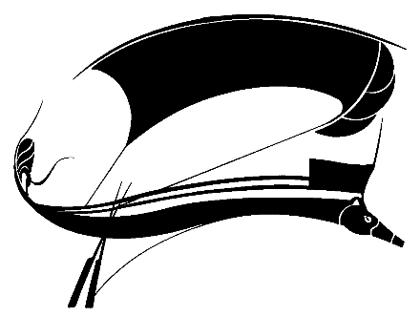

Aethlon: The Journal of Sport Literature

Spring-Summer 2020

Call for Submissions

*Aethlon: The Journal of Sport Literature* is looking for exciting, innovative work for publication. We are a print journal designed to celebrate the intersection of literature with the world of play, games, and sport. *Aethlon* publishes works about sport and sport literature, including original fiction, poetry, creative nonfiction, juried scholarly and critical essays, and book reviews. We are also interested in work in translation, as well as work pertaining to international sport.

For more information please contact Mark D. Baumgartner, Editor (baumgartnerm@etsu.edu). For complete submission guidelines, please see our website (<http://www.uta.edu/english/sla/aethlon.html>)

*Aethlon* has been in continuous print publication since 1983, and is indexed by the Modern Language Association, Humanities International Complete, ThomsonGale, Ebsco, and LA84. Subscription to the journal is included with membership in the Sport Literature Association (SLA).