By David Leonhardt
Good morning. Many parents want to continue remote learning. It may not be so good for their children.

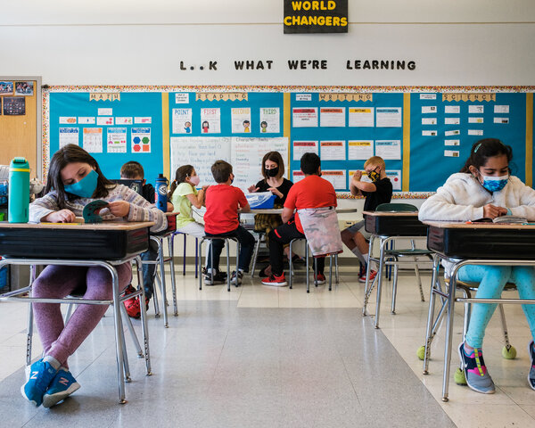
A third-grade classroom at Witchcraft Heights Elementary School in Salem, Mass., in April.Cody O'Loughlin for The New York Times

When school is voluntary
More than a century ago, U.S. states put in place laws requiring that children attend school. The guiding principle was that school mattered too much to children’s lives to be a matter of individual choice.

Helping on the family farm or getting a paid job was not a good enough excuse to drop out. Nor was parental convenience or preference. And students could not leave school simply because they wanted to.
Mandatory schooling laws did an enormous amount of good. They increased high school graduation rates and the share of students who attended college, as research by the economists Derek Messacar and Philip Oreopoulos has found. The extra schooling, in turn, lifted future earnings and reduced future unemployment.

But now Covid-19 is undermining the idea of universal schooling.
Officially, of course, the mandatory schooling laws remain in place. Children cannot legally drop out this fall. Yet many school districts have signaled that they will allow parents not to send their children to school in the coming academic year and instead learn remotely. Recent polls suggest that as many as one quarter of parents plan to keep their children home.

The families who choose to do so will span every demographic group, but they are likely to be disproportionately lower-income, Black and Latino. Remote learning was more popular among these groups last year, and a recent survey of parents in Massachusetts suggests the same will be true this fall. “Parents of color have been consistently less enthusiastic about in-person school,” Steve Koczela, whose firm conducted the survey, has said.

‘Little or no progress’

The problem with remote school is that children learn vastly less than they do in person, according to a wide range of data about the past year and a half.
- Rand Corporation, a research group, found that students attending remote classes learned less English, math and science than students attending in-person school.

- An analysis by Opportunity Insights, a group based at Harvard, found that student achievement lagged with remote learning — and lagged the most for lower-income students.
- A study in the Netherlands found that “students made little or no progress while learning from home.”

- Individual teachers also say they notice the difference. As Meghan Hatch-Geary, a decorated high school English teacher in Connecticut, told Education Week, her students who struggled the most last year were those who remained fully remote.
Remote schooling, in other words, may be more akin to dropping out than it is to attending in-person school. “Many education experts say in-person instruction is the best way to help hasten an academic recovery for those who fell behind and to address emotional and social consequences after two disrupted school years,” Erin Richards of USA Today has written.

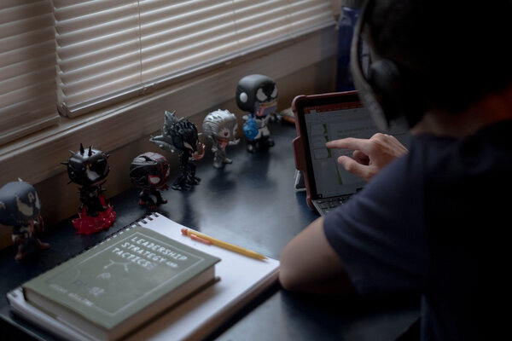
Eyan Gallegos, 11, a middle schooler in Washington, D.C., doing his homework.Gabriella Demczuk for The New York Times

The C.D.C.’s position

In response to the evidence, some school districts will mandate in-person attendance this fall — often with exceptions for the small share of families who are immunocompromised in a way that specifically puts them at greater Covid risk. Chicago, New York City and Washington, D.C., as well as much of Florida, Illinois and New Jersey, have taken steps in this direction.
The leaders of these districts have been encouraged by data showing that reopening schools did not lead to frequent Covid outbreaks, even before vaccines were widely available. (The C.D.C. emphasized this point last week, when urging schools to reopen and emphasizing the value of in-person learning.)

As Meisha Porter, the New York City schools chancellor, told the publication Chalkbeat: “We know our schools have been safe and we need our children back … Nothing, absolutely nothing, replaces the interaction and the learning that happens between a student and teacher in our classrooms.”
But most districts will continue to let parents choose between remote and in-person school, according to the national association of school superintendents.

‘Disrespectful’
There are no easy solutions here.

Black and Latino communities have suffered disproportionately from Covid, causing widespread anxiety about risks of sending children back to school. Lower-income communities also tend to have more vaccine skepticism, leaving many adults still vulnerable to the virus, albeit voluntarily so. These concerns have caused anger among parents in some districts that are mandating in-person school.
Tafshier Cosby, a New Jersey resident and an official with the National Parents Union, told Education Week that the decision by Gov. Phil Murphy to require in-person school was “doing parents a disservice” and “disrespectful.”

The situation reminds me of the historical debate over mandatory schooling laws. They sometimes inspired intense opposition from parents who thought that they — and not the government — should decide whether their children stayed home or went to school. Ultimately, though, societies decided that the long-term damage from missing school was too great.
The misery of Covid has frequently forced difficult choices. In the case of in-person school, the evidence seems to fall pretty strongly on one side of the debate. Serious Covid symptoms are extremely rare for children, making Covid less dangerous for them than many everyday behaviors (like riding in a car). Safe, effective vaccines are available for the overwhelming majority of U.S. adults and teenagers. Remote schooling has failed by virtually any measure, and there is no reason to believe it will work better this fall.

But I understand that many parents remain frightened by in-person school. The most likely outcome of continued remote learning, unfortunately, is yet another force that contributes to rising economic inequality in the U.S.

