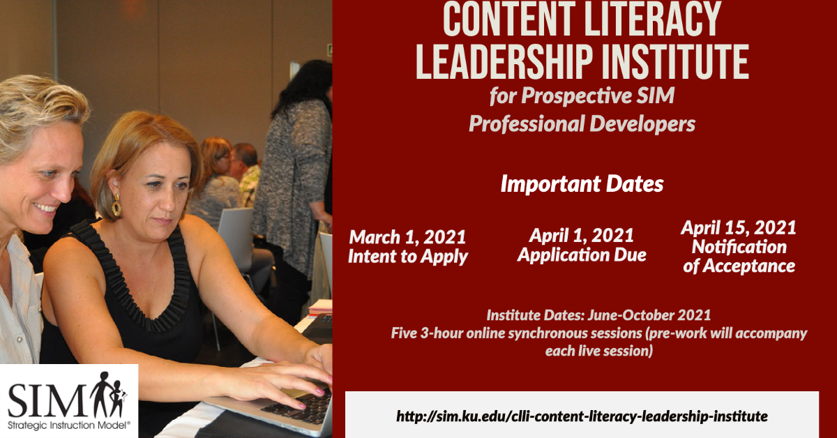

The University of Kansas Center for Research on Learning will offer both

Content Enhancement Routine and Learning Strategy strands

for prospective Strategic Instruction Model (SIM) Professional Developers

during the 2021 Content Literacy Leadership Institute (CLLI).

This institute will be fully online with both synchronous and asynchronous learning.

**Click here for more information or to register online today**

<http://sim.ku.edu/clli-content-literacy-leadership-institute>

[Sign up to join us](https://docs.google.com/forms/d/e/1FAIpQLSdBib0mC5PYyLcLH_SA9LcITA76ohYHgocZJSm36QH9p-Xd7A/viewform) on February 11th at 12:00 pm CST to listen to a brief overview and

ask questions about the process for becoming a SIM Professional Developer.