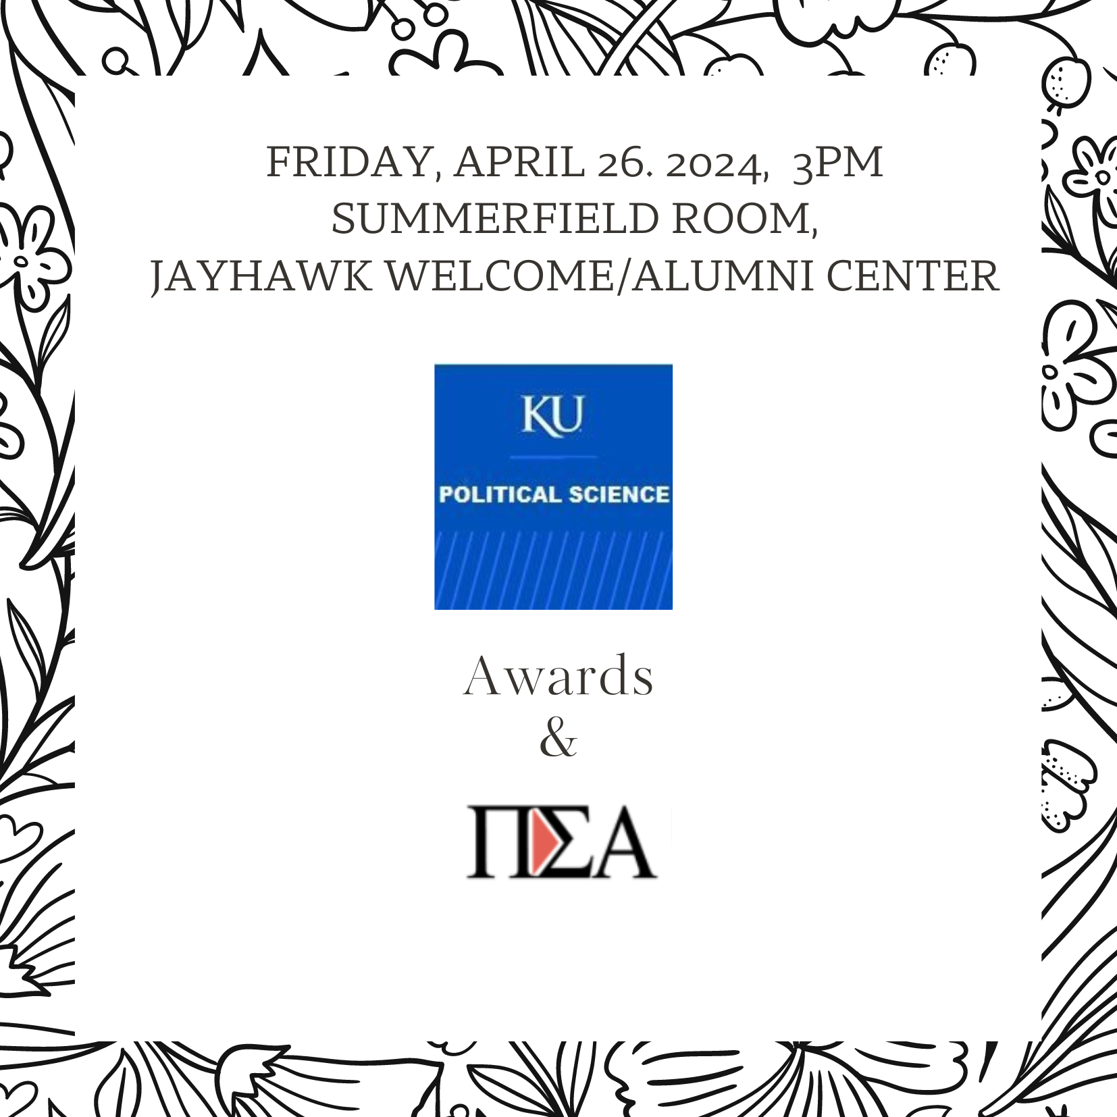

Welcome & Introductory Remarks
Professor John Kennedy, Chair
KU Political Science
Dr. Kevin Mullinix, Undergraduate Director
presentation of awards:
Pi Sigma Alpha inductees
Ethan Allen Pi Sigma Alpha Award
Emmett L Bennett Scholarship awards
Eldon Fields Pi Sigma Alpha Award
Gustafson Scholarship awards
Al Cigler Academic Enrichment awards
Faculty Pi Sigma Alpha Awards
(students completing Honors Theses)
Dr. Nazli Avdan, Graduate Director,
Comments & announcing Thompson awards
Congratulations!

Pi Sigma Alpha, KU Gamma Chapter
National Political Science Honor Society
2024 initiates
Alyssa Wilkes
Rita Pham
Grace Mechler
Whitney Lowe
Kristopher Long
Maggie Henery
Leishae Beerbower
Jack Benkelman
Natalie Fiorella
Jay Graganini
John Lubianetsky
Nick Caterine
Aalana Imani Omara Sherl
Sean Caroll

