**Schedule of Classes Key for Faculty/Staff (as of 8/5)**

**The options for course scheduling are:**

* **In-person**
* **Online – Asynchronous (Zoom or other – this will be listed as “online”)**
* **Online – Synchronous (Zoom or other – this will be listed as “online” with days/times)**
* **Hybrid – in-person with an asynchronous online component (online component will be determined by the instructor and will not be specifically scheduled to match the in-person meeting times for the course. The online component will be listed as “online”)**
* **Hybrid – in-person with a synchronous online component (meeting time for online is specifically scheduled. The online component will be listed as “online” with days/times)**
* **Cohort Structures –**
* **Courses that have a cohort that alternates WITHIN the same week on different days (e.g. a Tuesday cohort and a Thursday cohort) have two sections that essentially “flip” with each other so that half of the class meets at a time together.**
* **Courses that have a cohort that alternates weeks will have one section, but will list “alternate week” meeting times. In this case the instructor will assign students to the two cohorts.**

*\*\*\*Currently there are some errors in course set up. As a part of the key below, one example of a current format error is shown in red\*\*\**

**If you see a course set up that seems incorrect, please email the department scheduling officer. Their contact information can be found in the “notes” section of the course.**

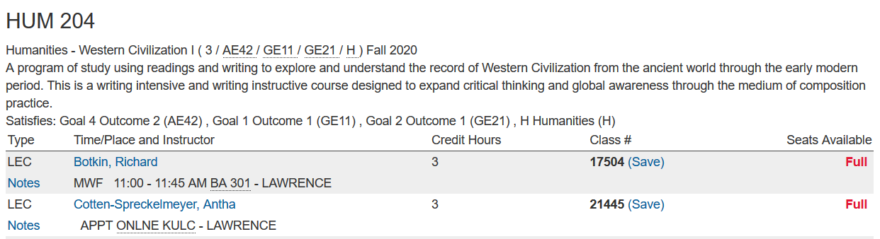

This is all **ONLINE-asynchronous**

This is all **IN-PERSON**

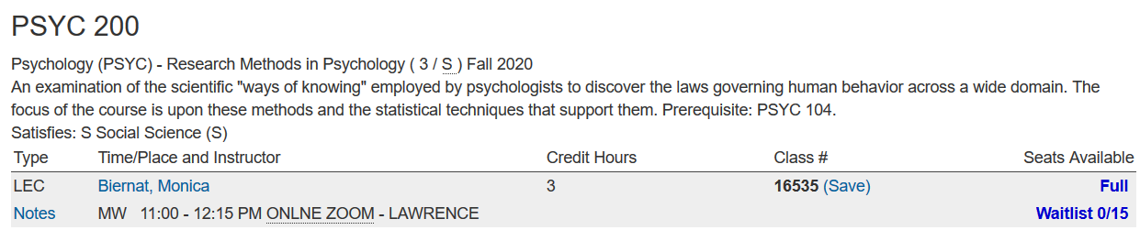

This is all **ONLINE-synchronous**

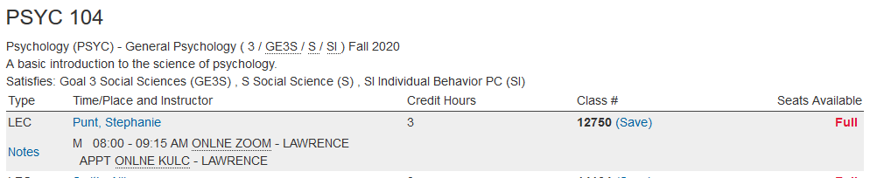

**ALL ONLINE, but with both synchronous and asynchronous components**

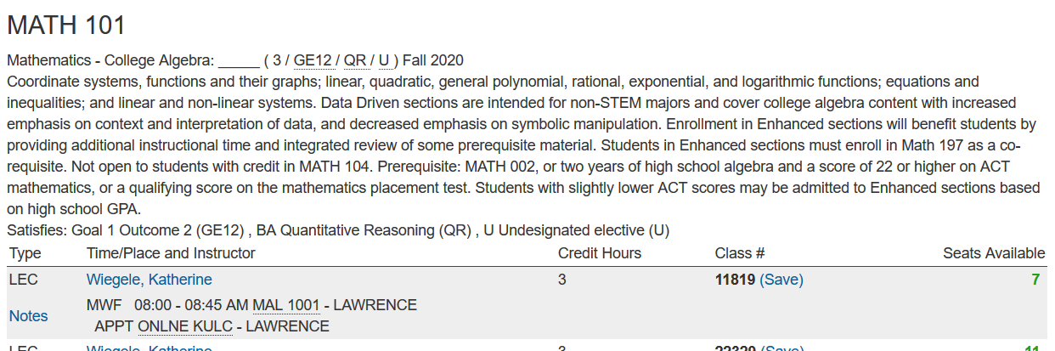

This is a **HYBRID course** with **asynchronous online** component determined by the instructor

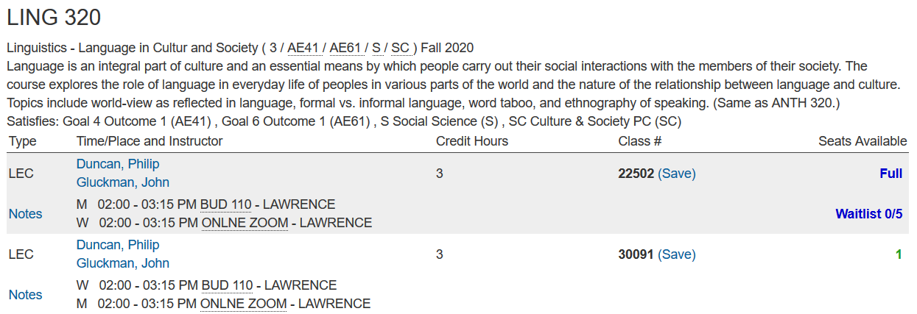

This is **HYBRID** course with **synchronous, alternating cohort** **by section**

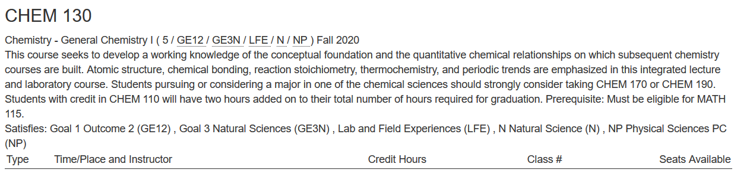

This is **HYBRID** course with **synchronous, alternating week cohort**



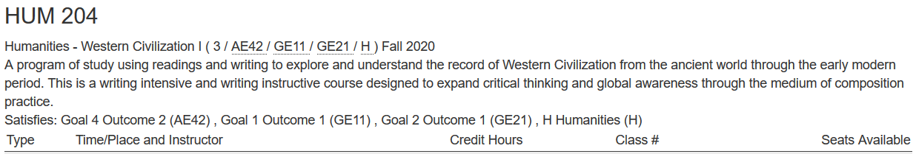

This is an error – APPT ONLINE ZOOM should not contain days of the week -



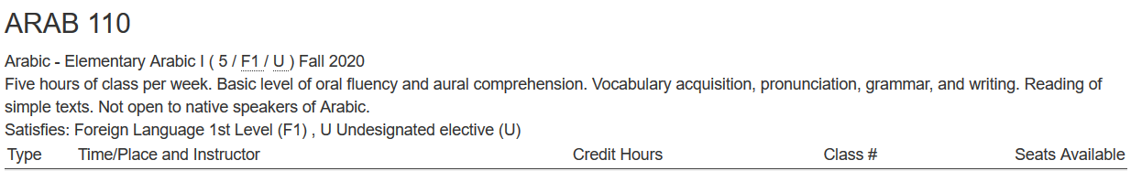

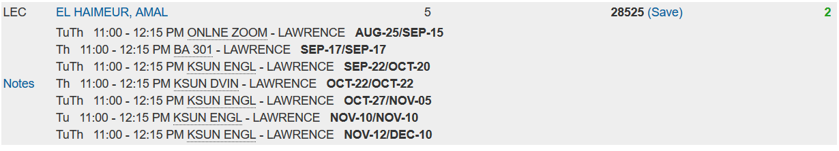

**HYBRID –** synchronous Zoom + multiple in-person rooms. Also contains error-course will not go until Dec. 10