Feeling the pinch: Economic shocks, the IMF and mass
mobilization
Kristian Skrede Gleditsch¹ & Gerald Schneider²

Financial crises and the reform demands that the International Monetary Fund (IMF) attaches to its rescue packages are often held to trigger social unrest. We evaluate the relative impact of different types of crises and IMF programs on mass mobilization, using more detailed data on the onset of the economic shocks and the agreement of the affected country with the IMF on a rescue package, and distinguishing between violent and nonviolent dissent. Our analysis used quarterly conflict data and takes into account the endogenous nature of IMF lending to countries that experience a banking, currency or sovereign debt crises. Although financial stress increases the likelihood of nonviolent protest, we demonstrate that IMF interventions actually decrease the risk of new conflict, consistent with a potential accommodating effect of lending and adjustments in countries that pass the screening criteria. Furthermore, we find no evidence that IMF programs increase the risk of political violence in crisis-ridden countries.

¹ Department of Government, University of Essex, UK; Peace Research Institute Oslo, Norway; Graduate School of Decision Sciences, University of Konstanz, Germany. Email: ksg@essex.ac.uk
² Department of Politics and Public Administration and Graduate School of Decision Sciences, University of Konstanz, Germany. Email: Gerald.Schneider@uni-konstanz.de
Previous versions of this manuscript have been presented at workshops at the University of Essex, the University of Houston and the University of Konstanz. We would like to thank Charles Butcher, Hyeran Jo and Ryan Kennedy as well as the other participants for helpful comments and suggestions. We gratefully acknowledge research support from the Alexander von Humboldt Foundation through an Anneliese Meier Award to Kristian Skrede Gleditsch. We would like to thank Christoph Dworschak, Rahel Kröker, and Pattamon Poonsiri for excellent research assistance.
Introduction
Two months after the overthrow of President Slobodan Milošević in October 2000, the International Monetary Fund (IMF) agreed to grant membership to the Federal Republic of Yugoslavia and to lend 151 million U.S. dollars in a rescue package to help the fledgling post-conflict country overcome the economic and financial crisis. The IMF funding helped bring to an end the ongoing anti-government protests that had started with strike action in the Kolubara coalfield 30 miles south of Belgrade. Many have stressed IMF lending as a cause of political turmoil and opposition to intrusive measures. However, in Serbia, the anti-government protests faded after the IMF package, despite of the strict conditions stipulating that the new government must impose austerity measures and take steps to liberalize the economy. This crisis scenario runs counter to classic theories of crises and political conflict and to current arguments by IMF critics that see its programs and conditional lending during economic crises as a key driver of social unrest and conflict. We argue in this article that many conjectures about the role of the IMF in promoting conflict after financial crises overstate the direct negative effect of the politics of conditionality and fail to appreciate the overall Keynesian logic of the more recent crisis interventions. We contend that contributions to the management of financial crises by the international financial community can actually lower the risk of more disruptive domestic conflict, once we take into account how IMF interventions are endogenous and are more likely to occur precisely during crises when the risk of conflict will be higher in the first place.
The role of international finance before and after economic crises has held a central place in the analysis of social conflict. Marx and Engels (1848) famously maintain in the Communist Manifesto that social conflict will arise in the aftermath of the inevitable recessions brought about by a volatile capitalist economy. Deprivation theorists expect that those who suffer during in economic crises will channel their anger into political mobilization (Davies 1962, Gurr 1970), and sociological theories of conflict highlight how power relationships that mediate conflict between competing social groups can be disrupted during crises (Dahrendorf 1959). Political economists similarly maintain that mobilization and distributional conflict between contending groups over who should shoulder the pain of adjustment will figure prominently, and often may prevent societies from introducing the necessary reforms (Alesina and Drazen 1991).
There are many historical examples where severe economic downturns appear to have sparked mass mobilization and conflict. The Great Depression in the 1930s activated both left and right-wing groups around the globe, and contributed significantly to the rise of fascism (de Bromhead, Eichengreen and O´Rourke 2014). Towards the end of the Cold War, Socialist governments in the Warsaw Pact countries collapsed following popular protests, but these were also fueled in part by the economic decline and internal contradictions of the Soviet-style planned economies (Bunce 1999). More recently, many Arab countries saw a considerable decline in global foreign direct investment after 2008, as the fallout of the Lehman Brothers’ bankruptcy spread, which led to more forceful demands for political change (Aziz and Mishra 2016). Ulfelder (2009: 28) concludes that “[I]n most instances, poor economic growth produced declines in living standards that spurred popular rebellion.”
However, the nexus between economic shocks and political mobilization is at the same time less direct and clear-cut than often assumed. One the one hand, both initiating as well as sustaining popular collective action is always difficult, even if individual have extensive grievances and motives. Anti-austerity movements like Occupy Wall Street have tried to globalize the social discontent following the new Great Recession, yet the uptake has been limited, and the success of the initial mobilization quickly ebbed away (Genovese, Schneider and Wassmann 2016). On the other hand, governments, their key agencies, and international financial institutions are not simply passive bystanders in economic crises, and their actual responses and their consequences can shape the motives and prospects for mobilization in important ways. More specifically, governments and international organizations possess various fiscal and monetary instruments that can counteract socially corrosive outcomes, even if fiscal constraints and ideological orthodoxy sometimes may prevent governments from using these tools efficiently to reduce the social and political fallout from crises.
Deficit reduction during financial or economic crises frequently has important social costs, and these can destabilize countries that adopt ill-timed austerity measures. Analyzing the time span from 1919 to 2008, Ponticelli and Voth (2011) argue that there is a strong and possibly causal link between austerity measures and different types of social unrest. Richards and Gelleny (2006) similarly show that banking crises increase the risk of nonviolent protests, although they do not appear to affect the risk of civil war onset. Martin and Gaby (2013) establish a link between the size of government debt and the amount of fiscal protests that a country endures.
International lenders such as the IMF commonly ask for structural reforms as a precondition for agreeing on a financial rescue package. Some critics see these externally imposed austerity measures as an impediment to successful crisis management. Stiglitz (2002), for example, deplores how the uniform application of the IMF programs and the underlying “Washington Consensus” has destabilized borrowing countries. Early studies on the economic impact of IMF lending suggested that structural adjustment programs have lowered rather than strengthened economic growth (Barro and Lee 2005, Przeworski and Vreeland 2000, Vreeland 2003). However, some recent studies paint a more positive picture (Bas and Stone 2014, Binder and Bluhm 2017).
Studies on the nexus between IMF program participation and the risk of conflict or civil war have reached seemingly inconsistent results. Hartzell, Hoodie and Bauer (2010) argue that conditional lending increases the risk that a country will see civil war. However, Midtgård, Vadlamannati and de Soysa (2014) reject this finding, and show that small modifications in the research design and lowering the threshold for violent conflict to 25 deaths actually suggests a negative effect. Recent studies have furthermore established that IMF lending supports rather than undermines democratization processes, which in the long run may help decrease political conflict (Birchler, Limpach and Michaelowa 2016, Nelson and Wallace 2016).
This article links the debates on the potential for social conflict after financial crises and the implications of conditional IMF lending. We examine how financial crises and inflation as well as IMF program participation affect the risk of conflict, distinguishing between violent conflict and nonviolent protests, taking into account the close relationship of IMF program participation to crisis conditions. Our study moves beyond the existing contributions to the two literatures in four ways. First, we go beyond the exclusive focus on lethal violence, which is the only form of conflict examined by Hartzell, Hoodie and Bauer´s (2010) pioneering study as well as the Midtgård, Vadlamannati and de Soysa’s (2014) reanalysis. This is important, since we expect that IMF programs should be more likely to trigger new urban protest rather than ethnic or rural violent conflict typically recorded in data on armed civil conflict. We contrast and explicitly compare the effects of crises and IMF programs on violent and nonviolent protests. Second, our research design takes into account the endogenous nature of IMF interventions, since IMF lending is extended to countries that are already in crisis, using the number of IMF staff in a potential crisis state as the main instrument for IMF programs. Third, we use quarterly data in order to avoid the possible bias in annual aggregation and to ease the typical temporal identification problems encountered in existing research. Our results indicate that financial crises as well as measures of their impact increase the risk of mass mobilization, but that IMF program participation actually reduces nonviolent social protests and does not affect the risk of political violence in any systematic way.

Crises, compensation and mobilization: Theory
There is growing interest in anti-government mass mobilizations, following the Arab Spring and other prominent uprisings around the world. One important insight of this emerging literature is that nonviolent mass uprisings spurred by economic crises tend involve different relevant actors and events than those emphasized in the study of conventional civil wars. Whereas many civil wars are involve discriminated ethnic groups seeking secession or greater autonomy, mass mobilizations are normally directed at the government or regime and more likely to be non-sectarian. Moreover, separatist conflicts often take place in the disputed areas in the periphery, often with small armed groups using the tactics of guerrilla warfare, while anti-government uprisings typically occur in core cities, and their impact on the government depends on presence in the capital and effect on the formal economy.
Economic factors and crises figured prominently in the early research on relative deprivation as a motivation for political protest (see Davies 1962; Gurr 1970). However, the backlash against grievance-based explanations may have gone too far in emphasizing political resources and opportunity structures. Since recent research has focused primarily on the political factors motivating anti-government mass mobilization, such as demand for political reform in autocracies, there has been a relative neglect of how political grievances may be influenced by economic grievances and crises. Although the Egyptian revolution called for the ousting of President Mubarak, many observers see the underlying economic hardship as one of the key factors that fueled political discontent (e.g. Malik and Awadallah 2013).
Much of the recent research on economic crises and protests has emphasized the role of structural adjustment programs imposed by the IMF. In general, critics of the IMF see government turnovers and political instability in countries such as Argentina as confirmation of the deep flaws of the “Washington Consensus” and how this undermines the social order of fragile countries (e.g. Chua 2002, Stiglitz 2002). Journalist Naomi Klein (2007:343) maintains that the Bretton Woods institutions frequently take part in shock therapies that turn a “crisis into catastrophe”. Yet, since IMF programs are often introduced after an economic shock, it is difficult to disentangle whether the crisis itself, or rather the rescue package and austerity conditions, drive mass protests.
To better understand the linkage between crisis and social mobilization, we distinguish between a direct and an indirect causal path. The direct link follows the logic of the grievance conjecture, relating economic shocks to subsequent protest. The indirect link also starts with the crisis, but then considers how interventions by the governments or an international organization can have a potential mediating influence and ameliorate the direct consequences.

The direct link
Crises decrease satisfaction with incumbent politicians and may motivate collective action through a number of avenues. Standard theories of economic voting posit that people are more likely to oppose incumbents or withdraw support when economic performance is poor (e.g., Fiorina 1978; Hibbing 1987; Stokes 1996). Outside voting in elections, people may respond to poor performance and a government perceived to be unresponsive using direct action to demonstrate discontent or to undermine the government and its ability to govern.
Much of the older literature related the mobilizing potential of economic crises to the psychological implications of worsening economic conditions. Individuals may remain acquiescent as long as the economy grows and they can aspire to a better future, but a decline in economic fortunes is likely to generate disillusionment and frustration that may lead to rebellion or rioting (e.g., Davies 1962; Gurr 1970). Dorsch et al. (2015) argue that economic shocks increase the likelihood of anti-regime protest because the population blames the elites, and they present empirical results consistent with their expectations. Economic crises can also help lower the opportunity costs of political action through decreasing the forgone benefits from participation in the formal economy (see Collier and Hoeffler 2004, Miguel et al. 2004, as well as Schneider 2014 for a critical discussion). Finally, specific government responses to crises may create important focal points that allow for mobilization, such as strikes or demonstrations called in response to specific crises measures or following unpopular policy announcements.
Much of the existing literature has focused on how dissent emerges in response to adverse circumstances, but not paid much attention to the different types of dissent that may be used. There has been more attention to effects of economic crises on political violence than nonviolent protest, even though many of the most prominent cases of anti-regime mobilization are nonviolent. Widespread discontent may allow mobilizing larger numbers for effective nonviolent dissent than for violent dissent, as nonviolent dissent requires few prior skills and has lower risks and barriers of entry than organized rebellion, at least once existing initial participation has crossed a minimum threshold (e.g., Bhavnani and Jha 2014; Chenoweth and Stepan 2011; Dahl et al. 2017; De Nardo 1985). As such, we should expect a more direct impact of economic crises on the prospects for nonviolent mobilization than on organized violent rebellion.

The indirect link
Governments and international financial institutions possess various fiscal and monetary tools to mediate the impact of economic shocks on their citizens, and this should in turn affect the potential for dissent. Keynesians advocate fiscal stimuli as a means to counteract the recessionary tendency after an economic shock, but some political economists stress how deficit reductions can reach the same goals. The latter school of thought hopes that by “reducing spending rather than by increasing taxes—budget consolidations are not harmful, and might indeed result in a boost to GDP” (Perotti 2013: 307). Alesina and Ardagna (2010) provide support for this thesis in an influential empirical study of fiscal consolidations in the OECD area, arguing that austerity measures can serve as a commitment device to deal with the crisis now rather than later, and have a positive effect on labor market expectations. This recommendation is based on the insight that certain social groups mobilize to preempt the implementation of anticipated reform measures that target them disproportionally. Alesina and Drazen (1991) model the interaction between contending social groups as a war of attrition game, where both sides rally to force the other to carry the burden of adjustment. The incentives to hold out as long as possible provides a rationale for why social mobilization increases before decisions are made on political reforms following an economic shock (Magee and Massoud 2011).
Jordá and Taylor´s (2016: 249) careful empirical analysis casts doubt on the growth-through-austerity thesis. Concluding that “Keynes was right after all”, they show that absolute GDP-reduction through austerity outweighs the gain of equivalent measures undertaken during boom years. Although governments should employ counter-cyclical fiscal measures following an economic shock, they might not have the capacity to do so. Among the member states of the European Political and Monetary Union, the Stability and Growth Pact limits the possibility to employ discretionary fiscal policies during times of crises. Countries that are already heavily indebted risk making matters even worse through the hyperinflation that a fiscal stimulus might create. Since printing money has the same effect, governments have frequently moved to devaluations to stimulate their economies or through unorthodox measures such as quantitative easing. Governments, however, do not prefer to depreciate their currencies as they risk being voted out in the aftermath of such a “humiliating” experience (Walter 2009), and members of a monetary union have lost their ability to pursue this option altogether. Interest rate policies and the New Keynesian monetary tools have indeed been shown to reduce the potential of social mobilization within the European Union (Genovese, Schneider, and Wassmann 2016), but it is unclear if they can be effective in less mature markets.
The fact that domestic policy options are constrained during times of financial stress is a key reason why countries may turn to the international community and especially the IMF for assistance. The IMF started to link loan disbursement to political conditionality during the debt crisis. The IMF-mandated prescriptions often include fiscal austerity, macroeconomic stabilization, the downsizing of the public sector, trade and capital account liberalization, and deregulation. Yet, critics of the Bretton Woods organization maintain that the implementation of the measures recommended in the former reform blueprint “Washington Consensus” worsens the crisis and also backfires in the form of increased social protest. This pattern was already observable at the beginning of the Latin American debt crisis in the late 1970s and early 1980s. According to Walton and Ragin (1990: 877), “a wave of austerity protests has occurred in 26 of the approximately 80 debtor countries”, with “overurbanization” and the involvement of IGOs in domestic affairs being the key drivers of the mass revolts. In his widely discussed polemic Globalization and its Discontents, Stiglitz (2002: 20) anticipated such riots as a consequence of the “international system of globalization under the aegis of the IMF”. The empirical evidence assembled by Oberdabernig (2013) appears to show that IMF programs have increased poverty and inequality, at least in the short run, even though this trend has reversed after 2000.
Trade theory provides a rationale for mobilization by those who fear that they may lose out from the introduction of market-oriented reforms. In terms of the likely winners and losers of economic reform, the Heckscher-Ohlin model suggests a division between factors or classes as the key feature of trade policy making. It predicts that actors tied to the abundant factors in an economy will be winners, thus likely to favor and support a liberalization process, while actors associated with the scarce factors will be worse off and hence oppose free-trade reforms. The Ricardo-Viner model distinguishes between export-competing and import-substituting sectors, and considers how not all factors may be mobile between the different sectors. Thus, sector-specific production factors cannot easily shift from one industry to the next, or shifts will at a minimum entail additional adjustment costs. In the case of economic liberalization, the opponents comprise the import-competing sector, senior officials in danger of losing their power and the unions of this sector, whereas entrepreneurs in export industries (as well as their employees) and, to some extent, consumers should support these reforms (for a more detailed discussion see Schneider 2014). These fears were expressed in the early anti-austerity protests analyzed by Walton and Seddon (1994:49–50), where ‘‘[c]rowds from Rio to Rabat crying ‘Out with the IMF!’ demanded a restoration of food and transportation subsidies, employment, and wages commensurate with inflation.’’
The conjecture that IMF programs mobilize potential losers of the reforms has found some support in empirical studies, but the results seem to depend on the measure of mobilization. Looking at evidence from twenty-three African and seven Latin American countries, Morrison (1996) shows that adjustment programs can be politically dangerous. However, he concludes that reactions to reforms depend on the specific measure implemented, and observes an average delay of three to six months between the announcement of a measure and a response in the form of demonstrations, strikes or protests to it. In another early study, Auvinen (1996) finds mixed support for the thesis that the politics of conditionality trigger mass protests.
Some studies have linked austerity measures and IMF programs to other forms of social mobilization. Bussmann and Schneider (2007) associate increases in foreign economic openness – one of the standard recommendations associated with the Washington Consensus – with a growing risk of civil war. Magee and Masdoud (2011) see this danger as looming the largest some years before the economic reforms reach their maximal level. Hartzell, Hoddie and Bauer (2010) suggest that the IMF-path to liberalization increases the risk of civil war. Midtgård, Vadlamannati and de Soysa (2013), conversely, demonstrate that this finding only holds when imposing a high conflict threshold and using specific criteria for IMF involvement, and argue that IMF programs appear to reduce the risk of lower-scale conflicts. Casper (2017) establishes a positive link between participation in IMF programs and the risk of coups d’état, while Dreher and Gassebner (2012) demonstrate that that the association between IMF presence and government crises vanishes once one considers the endogeneity of lending arrangements. Papi, Presbitero and Zazzaro (2015) show that borrowing countries can reduce the risk of a banking crisis in comparison to states that do not receive IMF loans.
As governments only call upon the IMF and possibly agree on its lending terms when they have an urgent economic need to do so, tests of the linkage between crises, austerity programs and social protests must consider the endogeneity of IMF programs. We also believe that it is necessary to differentiate between different forms of social mobilization and that the possible impact of IMF programs might be biased downwards because of a temporal over-aggregation. The next section details how we address these methodological challenges.

Data and Research Design
Data
We construct a quarterly global data set with indicators of protest, violent conflict events, and IMF programs and their conditionality, ranging from the first quarter in 2001 through 2015. The beginning of the temporal domain is limited by the availability of the event data that we use for measuring protest, namely the Integrated Conflict Early Warning System (ICEWS) event data, machine coded from news media report, developed for the US Political Instability Task Force (Boschee et al. 2015). ICEWS does not include domestic events for the USA, due to US federal government restrictions on funding for research with potential impact on domestic affairs. The raw ICEWS data contain information on individual events, identifying actors and targets, specific types of events, as well as the date where the reported event is deemed to have taken place. We consider only domestic events (i.e., actor and target are in the same country) with WEIS/CAMEO codes starting with 14XX (see Schrodt 2011: 66-72 for a description of the different types of events included).
We extract violent events from the Uppsala Conflict Data Program’s Georeferenced Event Dataset (see Sundberg and Melander 2013). These events also indicate sender and targets, types of violence (i.e. state-based conflict, non-state conflict, or one-sided violence) as well as the start and end date of episodes. We consider all ongoing domestic violent events in a quarter, but do not include interstate violence or events that take place outside the territory of a state.
Since we use quarterly data it is more informative to consider the absence/presence of protest events rather than counts of events. Biggs (2017) points out that most arguments on protest intensity pertain to size in terms of the numbers mobilized rather than the number of reported events. Count of events are sensitive to delineation of separate events and the number of reported sources over subsequent days, and has no inherent relationship to the number of participants or the scale of the event. We use a simple transition model between spells of events/no-events, and consider how covariates affect the likelihood of entry into and out of spells of protest or violent conflict at any scale, based on the covariates observable at t-1. We estimate two separate models for transitions into and out of spells. (Estimating a model for transitions in both directions as a single equation would yield identical results since the variance in limited dependent variable models must be set to 1 for identification.)
For IMF programs we have exact start and end dates taken from formal arrangements involving countries. We code a dummy variable to flag periods where an IMF program starts in one quarter and code this as ongoing until the quarter in which the program comes to an end. We distinguish three different types of financial crises, using the original Leaven and Valencia (2013a, b) data on systemic banking crises beyond 2007. They define a systemic banking crises as situations where
a country’s corporate and financial sectors experience a large number of defaults and financial institutions and corporations face great difficulties repaying contracts on time. As a result, non-performing loans increase sharply and all or most of the aggregate banking system capital is exhausted (Leaven and Valencia 2013a, 4).
The timing of the crises are identified by “whether the crisis year coincides with deposit runs, the introduction of a deposit freeze or blanket guarantee, or extensive liquidity support or bank interventions” (2013a, 4).
The Leaven and Valencia data also flag currency crises and systemic debt crises. Following Frankel and Rose (1996), currency crises are defined as “a nominal depreciation of the currency of at least 30 percent that is also at least a 10 percent increase in the rate of depreciation compared to the year before” (Leaven and Valencia 2013a, 5). Finally, systemic debt crises are identified based on sovereign defaults to private lending and debt rescheduling.
Finally, we include the consumer price index (CPI) and the change in the CPI as direct measures of the impact of the economy. This is an important control variable for estimates of a country´s mobilization potential as either crises or IMF programs may have apparent effects on protest or violence that are due to the associated impact on the local economy rather than impact of the IMF or financial crises per se. To consider possible time dependence we also consider the amount of time since any previous dissent spell, as well as terms for the square and cube of time passed (Signorino and Carter 2007).
Studies on the impact of IMF programs on social mobilization or war have, with the exception of Casper (2017), not explicitly addressed the possible endogeneity of these interventions. Hartzell et al. (2010) estimate a bivariate probit model of IMF programs and civil war and allow for the errors to be correlated. However, their model contains no explicit identification or exogenous predictors to explain IMF involvement. In the absence of exogenous instruments, the bivariate probit model is only identified based on assumptions about the distribution of the error term (see Sartori 2003).
Studies on the impact of IMF participation on economic outcomes, by contrast, have a long tradition in seeking to account for the endogenous nature of the interventions by the Bretton Woods institution. Analyzing the impact of the IMF on economic growth, for example, Atoyan and Conway (2006) compare instrumental variable and matching approaches. A prior study by Barro and Lee (2005) suggests the share of a country’s own nationals working at the IMF can be a plausible exogenous instrument for an IMF program. Casper (2017) adopts this proposed instrument to study the impact of IMF on coups. The instrument is plausibly relevant, since it is likely to be easier for the IMF to develop programs for countries when they have staff with country-specific knowledge. We also believe that this is likely to satisfy the exclusion criterion, since it is difficult to imagine that the anticipated risk of protest would change prior national IMF staffing. A downside of the measure is that the available data are measured only at five year intervals and have limited variation over time. Hence, it will be difficult to distinguish the instrument from country fixed effects. However, fixed effects are not appropriate in a binary state transition model set-up, as it will exclude all observations from units without transitions between states.

Results
Descriptive analysis
We include data for a total of 17,544 country quarters, from the first quarter of 2001 to the last quarter of 2015. Figure 1 shows the start and end dates of IMF programs. About 10% of the observations contain an IMF program. Unsurprisingly, the IMF launched new programs most frequently in the aftermath of the collapse of the Lehman Brothers.
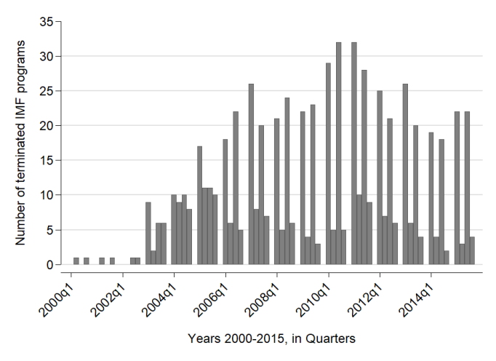
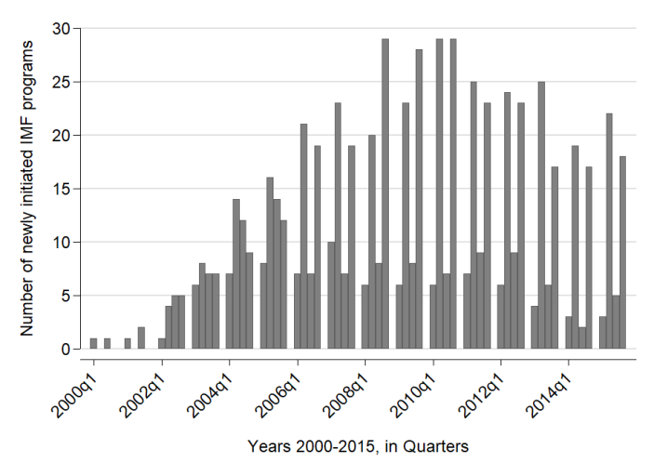

Figure 1: Start and end of IMF programs

Figure 2 shows the onset dates for the different economic crises in our data. When updating the initial Leaven and Valencia data it often proved difficult to identify conclusive end dates for crises. We have thus focused on identifying the precise starting periods here. In the original Leaven and Valencia data, the median duration of a crisis is two years, and the authors report that the main impact on real GDP occurs within the first part of the crisis. In order to maximize the data coverage in our analysis, we thus flag the subsequent eight quarters after the onset of a crisis as the period where the impact of the economic crisis is likely to be felt the most. Again, we observe the largest number of crises onsets in the wake of the 2007 financial crisis that transformed later on into the Great Recession in many of the affected countries.
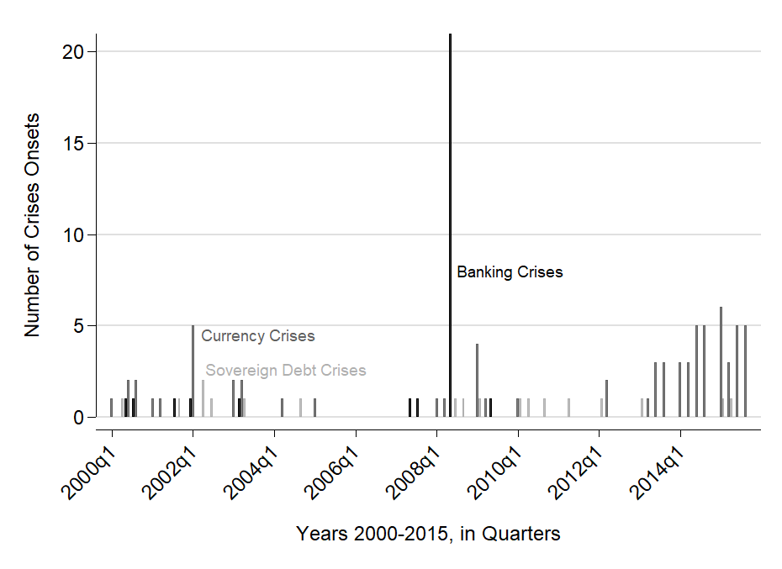

Figure 2: Crises start dates

In Figure 3 we display the total count of violent and nonviolent protest events by country quarters. In Table 1 we show the presence/absence of either event by country quarters. It is clear from these results that protest events are substantially more common than violent events in the UCDP data, i.e., events that occur in the context of a civil conflict with more than 25 battledeaths. The former occur in about 38.5% of the observations while the latter occur in only 10.7 %. And although most violent events also see protest, the reverse is not the case, as more than 3/4 of the protest incidents do not entail any violent events. As we have surmised, there is a higher overlap between IMF programs and the occurrence of nonviolent protests than between IMF programs and violence.
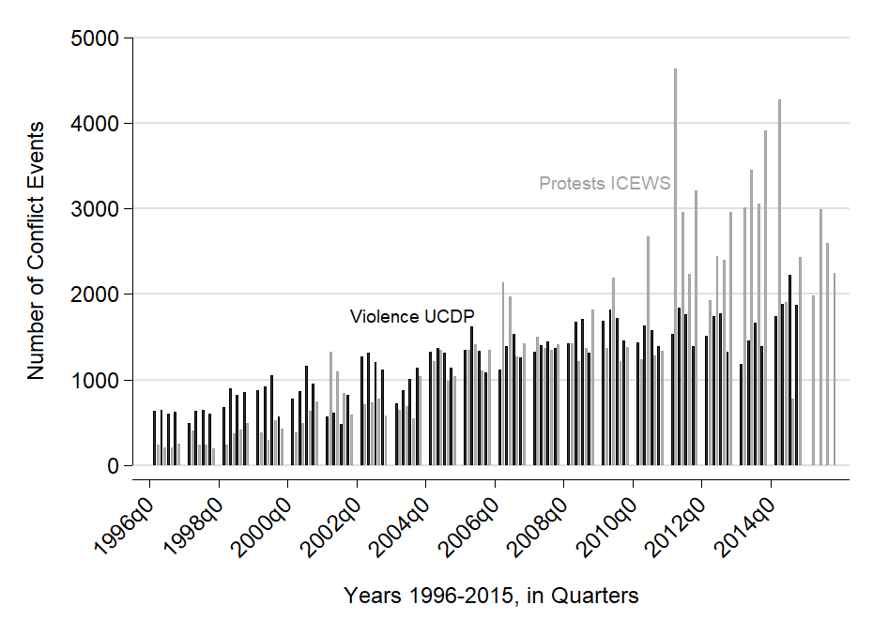
Figure 3: Number of violent (UCDP) and nonviolent protest (ICEWS) events by quarter and country

Table 1: Binary conflict by country quarter
 | No violence |  | Violence
 | (Percent) | (Percent)
No protest | 10,385 | 435
Protest | 5,290 | 1,434
Total | 1,675 | 1,869

We now proceed to examine how crises and IMF programs affect the likelihood of the onset of dissent, starting with transitions to nonviolent protest. In Model 1 in Table 2 we show the impact of our IMF program flag as well as each of the three crisis indicators. For the IMF period term we find a positive coefficient, consistent with the claim that IMF programs motivate protest. With regard to crises, we find positive coefficients for each of the three crises identified. However, only the term for currency crises is statistically significant.

Table 2: Protest onset
 | (1) | (2) | (3) | (4)
VARIABLES | Model 1 | Model 2 | Model 3 | Model 4
IMF program (lagged) | 0.41*** | 0.41*** | 0.22** | 0.23**
 | (0.09) | (0.09) | (0.09) | (0.09)
Sovereign debt crisis (lagged) | 0.29 |  | 0.27
 | (0.34) |  | (0.33)
Currency crisis (lagged) | 0.57*** |  | 0.50***
 | (0.14) |  | (0.15)
Banking crisis (lagged) | 0.14 |  | 0.08
 | (0.20) |  | (0.20)
Time since protest | -0.26*** | -0.26*** | -0.24*** | -0.24***
 | (0.01) | (0.01) | (0.02) | (0.02)
Time since protest^2 | 0.01*** | 0.01*** | 0.01*** | 0.01***
 | (0.00) | (0.00) | (0.00) | (0.00)
Time since protest^3 | -0.00*** | -0.00*** | -0.00*** | -0.00***
 | (0.00) | (0.00) | (0.00) | (0.00)
CPI (lagged) |  |  | 0.01*** | 0.01***
 |  |  | (0.00) | (0.00)
Change in CPI |  |  | 4.81*** | 4.90***
 |  |  | (1.00) | (0.99)
Any crisis (lagged) |  | 0.52*** |  | 0.43***
 |  | (0.11) |  | (0.12)
Constant | -0.31*** | -0.31*** | -0.97*** | -0.96***
 | (0.05) | (0.05) | (0.12) | (0.12)
Observations | 10,722 | 10,722 | 7,322 | 7,322
Log-likelihood | -3865 | -3865 | -3204 | -3205
Standard errors in parentheses
*** p<0.01, ** p<0.05, * p<0.1

The findings in Model 1 may reflect more the relative frequency of currency crises than actual differences in impact to other types of crisis. In Model 2 we replace the individual crises with a term flagging any crisis over a period. As can be seen, this fits the data about equally as well in terms of the log-likelihood as the model distinguishing between the three types of crises. This also suggests higher odds of protest following a crisis than after an IMF program.
In Model 3 we add a control for CPIs as a measure reflecting the impact of crises on the local economy. The results suggest that higher CPIs are associated with a higher likelihood of protest onset. Adding this to the model reduces the positive coefficient for IMF programs by almost half, while the crisis coefficients change much less. Model 4 replicates Model 3 with the joint term indicating any crisis. Again, the log-likelihoods indicate that the decrease in fit by combining all the measure in a single term is very small.
In Models 1 and 2 in Table 3 we report the results for estimates for transitions out of conflict, i.e. the likelihood that a protest spell will come to an end. Here we find a negative effect of crises as well as negative effects for CPI and changes in CPI. In short, these estimates indicate that crises cause protest to be more persistent. For IMF programs the coefficient is negative, but very small in comparison to crises, and not significant. As such, there is little support for the proposition that IMF programs make protest more persistent, over the impact of economic crises on sustaining protest.

Table 3: Protest termination
 | (1) | (2)
VARIABLES | Model 1 | Model 2
IMF program (lagged) | -0.09 | -0.10
 | (0.09) | (0.09)
Sovereign debt crisis (lagged) | -0.63**
 | (0.31)
Currency crisis (lagged) | -0.07
 | (0.15)
Banking crisis (lagged) | -0.04
 | (0.19)
Time since no protest | -0.32*** | -0.32***
 | (0.02) | (0.02)
Time since no protest^2 | 0.01*** | 0.01***
 | (0.00) | (0.00)
Time since no protest^3 | -0.00*** | -0.00***
 | (0.00) | (0.00)
CPI (lagged) | -0.00*** | -0.00***
 | (0.00) | (0.00)
Change in CPI | -2.41** | -2.61**
 | (1.15) | (1.14)
Any crisis (lagged) |  | -0.19
 |  | (0.12)
Constant | 0.68*** | 0.68***
 | (0.13) | (0.13)
Observations | 5,683 | 5,683
Log-likelihood | -2637 | -2638
Standard errors in parentheses
*** p<0.01, ** p<0.05, * p<0.1

In Table 4 we replace the protest response with violent conflict and estimate a comparable model of onset with the same covariates. A first result to note is that we find no evidence that economic crises have a positive effect on the onset of violence, unlike what we found for nonviolent protest. This is in line with our claim that economic factors are more likely to increase nonviolent rather than violent protest, as well as the notion that political violence is more likely to be related to political exclusion rather than short term economic changes. However, we still find a positive impact of IMF programs on initial onsets in Table 4, consistent with previous studies such as Hoddie et al. (2010).

Table 4: Transitions to/from violent events
 | (1) | (2) | (3) | (4)
VARIABLES | Model 1 | Model 2 | Model 3 | Model 4
IMF program (lagged) | 0.66*** | 0.66*** | -0.04 | -0.03
 | (0.16) | (0.16) | (0.18) | (0.18)
Sovereign debt crisis (lagged) | 0.35 |  | 0.29
 | (0.74) |  | (1.12)
Currency crisis (lagged) | -0.28 |  | 0.90***
 | (0.33) |  | (0.34)
Banking crisis (lagged) | -0.35 |  | 0.02
 | (0.60) |  | (0.68)
Time since violence | -0.24*** | -0.24***
 | (0.03) | (0.03)
Time since violence^2 | 0.01*** | 0.01***
 | (0.00) | (0.00)
Time since violence^3 | -0.00*** | -0.00***
 | (0.00) | (0.00)
CPI (lagged) | 0.01*** | 0.01*** | -0.00 | -0.00
 | (0.00) | (0.00) | (0.00) | (0.00)
Change in CPI | 0.68 | 0.56 | -4.38* | -4.05*
 | (0.83) | (0.81) | (2.48) | (2.45)
Any crisis (lagged) |  | -0.16 |  | 0.73**
 |  | (0.27) |  | (0.30)
Time since no violence |  |  | -0.31*** | -0.31***
 |  |  | (0.03) | (0.03)
Time since no violence^2 |  |  | 0.01*** | 0.01***
 |  |  | (0.00) | (0.00)
Time since no violence^3 |  |  | -0.00*** | -0.00***
 |  |  | (0.00) | (0.00)
Constant | -2.76*** | -2.76*** | 0.96*** | 0.96***
 | (0.21) | (0.21) | (0.25) | (0.25)
Observations | 11,236 | 11,236 | 1,769 | 1,769
Log-likelihood | -972.5 | -973.0 | -604.1 | -604.6
Standard errors in parentheses
*** p<0.01, ** p<0.05, * p<0.1

When we turn to the termination of violent conflict in Models 3 and 4 in Table 4, we again find no evidence for any impact of IMF programs, but economic crises appear to accelerate the termination of violence. This seems contrary to the arguments and mechanisms that critics such as Hoodie et al. (2010) invoke, which suggest that IMF involvement should fuel and sustain ongoing violent conflict.
The results so far have been based directly on the observed data, and not considering the possible endogeneity of IMF interventions to economic crisis conditions. However, there may be important omitted variables that influence both the decision of the IMF to become involved and the likelihood of conflict. In Table 5 we estimate a recursive bivariate probit model, in which we add a second equation for IMF programs, using the share of IMF staff from a country as exogenous variation to predict to IMF programs. We focus on the results for protest first, shown in columns 1 and 2. As can be seen, we find a large coefficient for staff on IMF program, suggesting that the instrument is relevant for the outcome. The F test is 14, thus above the normal criterion for weak instruments. The estimated ρ parameter is positive and significant, suggesting that the unobserved residuals in the first stage regression for IMF programs also appear to have a positive impact on the second stage outcome (i.e., conflict onsets).
Table 5: Bivariate probit, conflict onset and IMF programs
 | (1) | (2) | (4) | (5)
 | Protest |  | Violence
VARIABLES | Onset | IMF program | Onset | IMF program
IMF program | -1.276*** |  | -0.320*
 | (0.10) |  | (0.19)
Any crisis (lagged) | 0.205*** | 0.098 | -0.068 | 0.259***
 | (0.07) | (0.09) | (0.12) | (0.06)
Years w/o protest | -0.111*** | -0.039***
 | (0.01) | (0.01)
Years w/o protest^2 | 0.003*** | 0.001
 | (0.00) | (0.00)
Years w/o protest^3 | -0.000*** | -0.000
 | (0.00) | (0.00)
CPI (lagged) | 0.009*** | 0.014*** | 0.008*** | 0.013***
 | (0.00) | (0.00) | (0.00) | (0.00)
Change in CPI | 2.962*** | 1.196 | 0.466 | 0.198
 | (0.59) | (0.84) | (0.35) | (0.37)
National IMF staff |  | -54.818*** |  | -49.580***
 |  | (7.11) |  | (4.24)
Years since last violence |  |  | -0.106*** | -0.035***
 |  |  | (0.01) | (0.01)
Years^2 |  |  | 0.003*** | 0.001***
 |  |  | (0.00) | (0.00)
Years^3 |  |  | -0.000*** | -0.000***
 |  |  | (0.00) | (0.00)
Constant | -0.731*** | -2.025*** | -1.637*** | -1.827***
 | (0.07) | (0.10) | (0.10) | (0.08)
Observations | 5,400 | 5,400 | 9,129 | 9,129
Rho | 0.832***  (0.067) |  | 0.361***  (0.112)
Log-likelihood | -4776 |  | -4371
Standard errors in parentheses
*** p<0.01, ** p<0.05, * p<0.1

The estimated result for IMF involvement on conflict in Column 1 in Table 5 is dramatically different from the previous transition model results, as the coefficient changes sign and becomes significantly negative. Hence, although we continue to find a clear positive impact of economic crises on protest, there is no longer any evidence to support that IMF programs stimulate protests once we take into account their relationship to crises – rather, IMF programs appear to make protest less likely. This is consistent with the idea that programs can have accommodating effects, and that countries that manage to pass through the IMF screening processes will have be more capacity to mitigate the impact of a crisis and hence are less likely to see protest than countries without IMF programs.
Columns 3 and 4 in Table 5 report the comparable results for a model of violent conflict. These results lend no support for the argument that IMF programs increase the risk of violent conflict onset. The coefficient is negative, although it is only statistically significant at the 0.10 level. In short, the results here may be somewhat less conclusive. We find a similar sign reversal, but the evidence for selection between the two equations is weaker in the sense that the estimated correlation between the residuals is lower, although it remains statistically significant. Note that although the predictors for IMF programs are the same, the residuals in the second equation for conflict onset will depend on the specific type of response, and the lower correlation for violent conflict may reflect that violent conflict is ultimately less clearly related to the economic factors associated with decisions to initiate IMF programs.
The results support our theoretical expectation that economic crises increase the mobilization potential in societies, but IMF interventions and international financial assistance actually stabilize societies in the short-term, even if the agreement of the participating governments to implement austerity measures and other reforms may hurt the interests of considerable shares of the society. One reason why social costs of the reform do not outweigh the fiscal relief of the related IMF credits might be that the restrictive measures of the rescue packages are carried out at a later stage, if they are implemented at all. Arpac, Bird and Mandilaras (2008) demonstrate that trade openness, the influence of veto players and modest resources allocated by the fund to a country in need increase the risk of irreversible reform implementation. Güven (2012, see also Chapman et al. 2017) maintains that powerful IMF “clients” can cherry-pick reform strategy, partly reflecting the different macro-economic experiences before the onset of a crisis.
A second important finding of our analysis is the rejection of the conjecture that IMF rescue packages instigate internal violence and war. Hartzel, Hoddie and Bauer’s (2010) influential article appears to provide empirical evidence in favor of the anti-globalization conjecture that the austerity measures prescribed by the IMF and other international actors incites violent conflict (see Chua 2002, Klein 2007). Midtgård, Vadlamannati and de Soysa (2014) have already raised concerns over the robustness of the finding, but our study is the first to properly identify IMF interventions, consider both violent and nonviolent conflict, and show that IMF interventions can appease rather than destabilize societies in the short-run through the inflow of credit.
Several cases support this macro-political evidence. Yugoslavia (Serbia), cited in the beginning of this article, illustrates how rescue measures of the International Monetary Fund can ease the social tensions within a country despite the austerity measures that go along with the inflow of fresh capital. An IMF loan and a U.S. bridge loan similarly helped the fledgling Uruguayan economy to recover relatively soon after the banking crisis of July 2002 that followed after the devaluations of the Brazilian Real and the Argentinean Peso in 1999 and 2001, reducing the GDP of the Latin American country by more than 10%. Taylor (2007: 95), who was acting in this period as Under Secretary of the Treasury for International Affairs in the Bush administration, attributes the success of these measures in part to his ability to convince the IMF to move away from its demand to restructure the Uruguayan debt massively: “The rapid provision of financial support bolstered confidence and enabled Uruguay to reopen the banks without a resumption of the bank run”.
The Great Recession posed even a greater challenge than the Latin American crises of the early 2000s. The Eurozone crisis necessitated several interventions by the European authorities and the Fund. A former executive director of the organization believed three years after the collapse of the Lehman Brother that the crisis management was quite positive: “A complete catastrophe was only averted by the resolute action of central banks, treasuries, and the IMF” (de Beaufort Wijnholds 2011: 190). Yet, the crisis continued, and The Economist (2013) forecasted for Greece, together with other instable countries such as Egypt or Venezuela, a “very high risk” of massive social unrest in 2014. In the wake of the Great Recession, the Greek economy experienced a similar crisis like the United States during the Great Depression, with a contraction of 25% of its GDP (IMF 2017: 10). However, the Greek troubles have lasted longer than the slump the U.S. economy endured in the early 1930s.
Most observers believe that the crisis management by the Troika - the European Commission (EC), the European Central Bank (ECB) and the IMF - deepened the depression further. Wyplosz (2017: 49-50) lists a couple of mistake European leaders have made, including assigning the role of the “bad cop” to the European Commission instead of the IMF: “…this led to disagreements with the IMF, which even let it be known that it found the program too harsh, but it also left a legacy of resentment that will not disappear.” It was the interventions by the third member of the Troika, the ECB, that, according to Genovese et al. (2016), eased the social tensions a bit, which manifested itself in a reduction of the number of general strikes. Wyplosz (2017: 57) similarly concludes “…that it was only when the ECB became active in 2012 that the crisis came under control.” Although the Eurozone member states and the IMF contributed the largest bailout package in history, it only slowed down the massive downturn of the Greek economy. The “structural adjustment” that came along with the financial assistance, deepened the crisis at least in the beginning. According to a macroeconomic simulation, the “inevitable” fiscal consolidations accounted for 50% of the output drop that the Eurozone member endured (Gourinchas et al. 2016: 4), while the stalling reform efforts in the mid-2010s hindered the Greek economy to recover more quickly.
Other crisis-ridden member states of the European Political and Monetary Union such as Ireland or Portugal recovered more quickly and implemented more of the required structural reforms than Greece. Gupta et al. (2018) show that newly elected, efficient governments with large majorities are more likely to live up to their promise to consolidate the finances of their state. According to the IMF, member states in which “country authorities, public opinion and the broader political establishment agree on what reforms are necessary and welcome them” have a much better track record (Thomsen 2017). This underlines that at least some of the social unrest that comes in the wake of financial crises has reached the goal of forestalling or at least slowing down some of the reforms that international lenders such as the IMF attach to the their fiscal assistance in times of crisis.

Conclusion
In this article we have reexamined the impact of economic shocks and IMF interventions on social mobilization, differentiating between violent and nonviolent social activism. We find that economic immiseration and crises can have a mobilizing effect, but this primarily pertains to nonviolent mobilization rather than political violence. Moreover, we demonstrate that once we take into account the impact on local economy and the endogenous nature of IMF involvement, IMF programs actually have a negative marginal impact on protest and no consistent effect on political violence. This contradicts the claims of Hartzel, Hoddie and Bauer (2010) that IMF-induced austerity fosters violent conflict, and rather suggests an accommodation effect that can mitigate conflict, especially nonviolent protest.
Our analysis does not differentiate between IMF programs of varying severity, nor does it take into account in much detail how severe the repercussion of a financial crisis were. The results nevertheless caution against attempts to see the International Monetary Fund as a lackey of the financial industry that solely brings havoc to the developing world. While some austerity programs mandated by the IMF might have worsened the situation of the borrowing countries especially during the heydays of the “Washington Consensus”, the capital flowing to these states has eased the social tensions at the average in the short run. This could also mean that the stimulating effect of IMF liquidity has by and large overshadowed the potentially stifling impact of the simultaneous austerity measures. This adds to the finding that monetary tools propagated by the New Keynesians can be used to reduce social unrest in advanced economies as well (Genovese, Schneider, and Wassmann 2016).

References
Alesina, Alberto, and Silvia Ardagna. 2010. Large Changes in Fiscal Policy: Taxes versus Spending. In Tax Policy and The Economy, vol. 24, edited by Jeffrey R. Brown, 35–68. Chicago: University of Chicago Press.
Alesina, Alberto and Allan Drazen. 1991. Why Are Stabilizations Delayed? American Economic Review 81(5): 1170-1188.
Alesina, Alberto, Roberto Perotti and José Tavares. 1998. The Political Economy of Fiscal Adjustments. Brookings Papers in Economic Activity – Macroeconomics 1: 197-266.

Almunia, Miguel, Agustín Bénétrix, Barry Eichengreen, Kevin O'Rourke, and Gisela Rua. 2010. From Great Depression to Great Credit Crisis: Similarities, Differences and Lessons. Economic Policy 25: 219–265.
Arpac, Ozlem, Graham Bird, and Alex Mandilaras. 2008. Stop Interrupting: An Empirical Analysis of the Implementation of IMF Programs. World Development 36(9): 1493-513.
Atoyan, Rouben and Patrick Conway. 2006. Evaluating the Impact of IMF Programs: A Comparison of Matching and Instrumental-Variable Estimators. Review of International Organizations 1 (2): 99–124.
Auvinen, Juha Y. 1996. IMF intervention and political protest in the third world: a conventional wisdom refined. Third World Quarterly 17(3): 377–400.
Aziz, Omar G. and Anil V. Mishra. 2016. Determinants of FDI inflows to Arab economies. Journal of International Trade & Economic Development 25(3): 325-356.
Barro, Robert J. and Jong-Wha Lee. 2005. IMF programs: who is chosen and what are the effects? Journal of Monetary Economics 52(7): 1245–1269.
Bas, Muhammet A. and Randall W. Stone 2014. Adverse selection and growth under IMF programs. Review of International Organizations 9(1): 1–28.
Bhavnani, Rikhil, and Saumitra Jha. 2014. Gandhi's Gift: Lessons for Peaceful Reform from India's Struggle for Democracy. Economics of Peace and Security Journal 9 (1):76-88.
Binder, Michael and Marcel Bluhm. 2017. On the conditional effects of IMF program participation on output growth. Journal of Macroeconomics 51: 192-214.
Birchler, Kassandra, Sophia Limpach and Katharina Michaelowa. 2016. Aid Modalities Matter: The Impact of Different World Bank and IMF Programs on Democratization in Developing Countries. International Studies Quarterly 60 (3): 427-439.
Boschee, Elizabeth, Jennifer Lautenschlager, Sean O'Brien, Steve Shellman, James Starz, and Michael Ward. 2015. ICEWS Coded Event Data. doi:10.7910/DVN/28075, Harvard Dataverse, V15.
Bunce, Valerie. 1999. Subversive Institutions: The Design and the Destruction of Socialism and the State. New York: Cambridge University Press.
Bussmann, Margit and Gerald Schneider. 2007. When Globalization Discontent Turns Violent: Foreign Economic Liberalization and War. International Studies Quarterly 51 (1): 79-97.
Casper, Brett A. 2017. IMF Programs and the Risk of a Coup d’état. Journal of Conflict Resolution 61(5) 964-996.
Chapman, Terrence, Songying Fang, Xin Li, and Randall W. Stone 2017. Mixed signals: IMF lending and capital markets. British Journal of Political Science, 47(2), 329–349.
Chenoweth, Erica, and Maria J. Stephan. 2011. Why Civil Resistance Works: The Strategic Logic of Nonviolent Conflict. New York, NY: Columbia University Press.
Chua, Amy. 2002. World on Fire: How Exporting Free Market Democracy Breeds Ethnical Hatred and Global Instability. New York: Doubleday.
Collier, Paul, and Anke Hoeffler. 2004. Greed and Grievance in Civil War. Oxford Economic Papers 56 (4):563-95.
Conway, P. 2007. The Revolving Door: Duration and Recidivism in IMF Programs. Review of Economics and Statistics 89(2): 205–220.
Dahl, Marianne, Scott Gates, Kristian Skrede Gleditsch, and Belen Gonzalez. 2017. Accounting for numbers: Actor profiles and the choice of violent and nonviolent tactics. Typescript, Peace Research Institute Oslo.
Dahrendorf, Ralf. 1959. Class and Class Conflict in Industrial Society. Stanford, CA: Stanford University Press.
Davies, John. 1962. Toward a Theory of Revolution. American Sociological Review 27:5-18.
de Beaufort Wijnholds, Onno. 2011. Fighting Financial Fires. An IMF Insider Account. New York: Palgrave Macmillan
de Bromhead, Alan, Barry Eichengreen, and Kevin H. O´Rourke. 2013. Right-Wing Political Extremism in the Great Depression. Journal of Economic History 73(2): 371-406
DeNardo, James. 1985. Power in Numbers: The Strategy of Protest and Rebellion. Princeton, NJ: Princeton University Press.
Dorsch, Michael, Karl Dunz, and Paul Maarek. 2015. Macro Shocks and Costly Political Action in Non-Democracies. Public Choice 162:381-404.
Dreher, Axel and Martin Gassebner. 2012. Do IMF and World Bank programs induce government crises? An empirical analysis. International Organization 66(2): 329-358
Dreher, Axel, Jan-Egbert Sturm, and James Raymond Vreeland. 2015. Politics and IMF Conditionality. Journal of Conflict Resolution 59 (1):120-148.
Easterly, William. 2005. What did structural adjustment adjust? The association of policies and growth with repeated IMF and World Bank adjustment loans. Journal of Development Economics 76(1): 1–22.
Fiorina, Morris. 1978. Economic Retrospective Voting in American National Elections: A Micro-Analysis. American Journal of Political Science 22 (2):426-44.
Genovese, Federica, Gerald Schneider, and Pia Wassmann. 2016. The Eurotower strikes back: Crises, adjustments and Europe’s austerity protests. Comparative Political Studies 49(7): 939-967.
Gourinchas, Pierre-Olivier, Thomas Philippon, and Dimitri Vayanos. 2016. The Analytics of the Greek Crisis. NBER Macroeconomics Annual 31 (1):1–81.
Gupta, Sanjeev, João T. Jalles, Carlos Mulas-Granados, and Michela Schena (2018) Planned fiscal adjustments: Do governments fulfil their commitments? European Union Politics 19(3)
Gurr, Ted R. 1970. Why Men Rebel. Princeton, NJ: Princeton University Press.
Gurr, Ted R. 1985. On the Political Consequences of Scarcity and Economic Decline. International Studies Quarterly 29(1): 51-75.
Güven, Ali Burak. 2012. The IMF, the World Bank, and the Global Economic Crisis: Exploring Paradigm Continuity. Development and Change 43(4): 86998.
Hartzell, Caroline A. and Matthew Hoddie, with Molly Bauer. 2010. Economic Liberalization via IMF Structural Adjustment: Sowing the Seeds of Civil War? International Organization 64(2): 339-56.
Hibbing, John R. 1981. On the Issues Surrounding Economic Voting: Looking to the British Case for Answers. Comparative Political Studies 20 (1):3-33.
Hutchison, Michael M. 2003. A cure worse than the disease? Currency crises and the output costs of IMF-supported stabilization programs. In M. P. Dooley & J. A. Frankel (Eds.) Managing currency crises in emerging markets (pp. 321–60). Chicago: University of Chicago Press.
International Monetary Fund 2017. Greece - 2016 Article IV Consultation. IMF Country Report, 17/40.
Jordà, Oscar and Alan M. Taylor. 2016. The time for austerity: estimating the average treatment effect of fiscal policy. Economic Journal 126 (590): 219–255.
Kentikelenis, Alexander E., Thomas H. Stubbs, and Lawrence P. King. 2016. IMF conditionality and development policy space, 1985–2014. Review of International Political Economy 23(4): 543-582
Klein, Naomi. 2007. The Shock Doctrine: The Rise of Disaster Capitalism. New York: Metropolitan Books.
Knight, Malcom, and Julio A. Santaella. 1997. Economic determinants of IMF financial arrangements. Journal of Development Economics 54 (2):405-436.
Laeven, Luc and Fabián Valencia. 2012. Systemic Banking Crises: An Update. IMF Working Paper 12/163.
Laeven, Luc and Fabián Valencia. 2013. Systemic banking crises database. IMF Economic Review 61(2): 225–27.
Malik Adeel and Bassem Awadallah. 2013. The economics of the Arab Spring. World Development 45: 296-313.
Magee, Christopher S. P. and Tansa George Massoud. 2011. Openness and Internal Conflict. Journal of Peace Research 48 (1): 1 59-72.
Morrison, Christian. 1996. The Political Feasibility of Adjustment. Policy Brief No.13, OECD.
Midtgård, Trude Mariane, Krishna Vadlamannati and Indra de Soysa. 2014. Does the IMF cause civil war? A comment. Review of International Organizations 9(1): 107–124.
Martin, Isaac William and Nadav Gabay. 2013. Fiscal protest in thirteen welfare states. Socioeconomic Review 11 (1): 107-130.
Marx, Karl and Friedrich Engels. 1848. Manifesto of the Communist Party. Available at https://www.marxists.org/archive/marx/works/download/pdf/Manifesto.pdf
Miguel, Edward, Shanker Satyanath, and Ernest Sergenti. 2004. Economic Shocks and Civil Conflict: An Instrumental Variables Approach. Journal of Political Economy 112 (4):725–53.
Nelson, Joan M. 1990. Economic crisis and policy choice: The politics of adjustment in the Third World. Princeton, NJ: Princeton University Press.
Nelson, Stephen C. and Geoffrey P. Wallace. 2016. Are IMF lending programs good or bad for democracy? Review of International Organizations 12(4): 1–36.
Oberdabernig, Doris A. 2013. Revisiting the effects of IMF programs on poverty and inequality. World Development 46: 113–42.
Owen, Erica and Noel P. Johnston. 2017. Occupation and the Political Economy of Trade: Job routineness, offshorability and protectionist sentiment. International Organization 71 (4): 665-699.
Papi, Luca, Andrea F. Presbitero and Alberto Zazzaro, A. 2015. IMF Lending and Banking Crises. IMF Working Papers 63(3), 644–691.
Perotti, Roberto 2013. The austerity myth: gain without pain? In Fiscal Policy after the Financial Crisis, Alberto Alesina and Francesco Giavazzi, eds., pp. 307–54, Chicago, IL: University of Chicago Press.
Ponticelli, Jacopo and Hans-Joachim Voth. 2011. Austerity and Anarchy: Budget Cuts and Social Unrest in Europe, 1919-2008. Economics Working Papers 1342. Barcelona, Spain: Department of Economics and Business, University Pompeu Fabra.
Przeworski, Adam, and James R. Vreeland 2000. The effect of IMF programs on economic growth. Journal of Development Economics 62: 385–421.
Richards, David L. and Roland D. Gelleny. 2006. Banking Crises, Collective Protest and Rebellion. Canadian Journal of Political Science 39(4): 777-801.
Sattler, Thomas and Stefanie Walter. 2010. Monetary Credibility vs. Voter Approval: Political Institutions and Exchange-Rate Stabilization during Crises. Economics & Politics 22(3): 392-418.
Schneider, Gerald 2014. Peace through globalization and capitalism? Prospects of two liberal propositions. Journal of Peace Research 51(2): 173–183.
Schrodt, Philip A. 2012. CAMEO: Conflict and Mediation Event Observations Event and Actor Codebook. http://data.gdeltproject.org/documentation/CAMEO.Manual.1.1b3.pdf.
Stiglitz, Joseph E. 2002. Globalization and its Discontents. London: Allen Lane.
Stokes, Susan. 1996. Public Opinion and Market Reforms: The Limits of Economic Voting. Comparative Political Studies 29 (5):499-519.
Stone, Randall W. 2008. The Scope of IMF Conditionality. International Organization 62(10): 589–620.
Stroup, Caleb and Ben Zissimos 2013. Social Unrest in the Wake of IMF Structural Adjustment Programs. In The Economics of Conflict: Theory and Empirical Evidence, Karl Wärneryd ed. Cambridge, MA: MIT Press, pp. 209-230.
Taylor, John B. 2007. Global financial warriors: the untold story of international finance in the post-9/11 world. New York: Norton.
The Economist 2013. Social unrest in 2014. Protesting predictions. https://www.economist.com/cassandra/2013/12/23/protesting-predictions (last consulted, July 25, 2018)
Thomsen, Poul. 2017. Structural Reforms in the Euro Zone: an IMF Perspective. http://www.imf.org/en/News/Articles/2017/10/23/sp101817-structural-reforms-in-the-euro-zone-an-imf-perspective (last consulted, July 26, 2018)
Ulfelder, Jay 2009. Pathways to Political Liberalization in Dictatorships. SSNR Working 1532791.
Vreeland, James R. 2003. The IMF and economic development. New York: Cambridge University Press.
Walter, Stefanie. 2009. The Limits and Rewards of Political Opportunism. How Electoral Timing Affects the Outcome of Currency Crises. European Journal of Political Research 48(3): 367-96.
Walton, John and Ragin, Charles. 1990. Global and national sources of political protest: Third world responses to the debt crisis. American Sociological Review 55, 876–90.
Walton, John, and David Seddon. 1994. Free markets and food riots: The politics of global adjustment. Cambridge, MA: Blackwell.
Wyplosz, Charles. 2017. The Eurozone Crisis: A Near-Perfect Case of Mismanagement. In: Bournakis I., Tsoukis C., Christopoulos D., Palivos T. (eds) Political Economy Perspectives on the Greek Crisis. Cham: Palgrave Macmillan, pp. 41-59.

There is a widespread consensus that the lack of counter-cyclical fiscal stimuli deepened the Great Depression (Almunia et al. 2010). Jordà and Taylor (2016: 220) estimate that a fiscal consolidation of the size of 1% of GDP translated into a “GDP loss of around 3.5% over five years” for the Great Recession, and that this effect dwarfed the positive effect of equivalent deficit reductions during economic booms.
The IMF moved away from this policy agenda in the 2000s. However, Kentikelenis, Stubbs and King (2016) claim that the IMF did not change the substance of its disbursement policy after 2008.
Task-oriented trade theory is furthermore helpful to understand how the routineness and the off-shorability of a job affects the welfare consequences of economic integration and the resistance against globalization. Owen and Johnston (2017) demonstrate that respondents who perform routine tasks and work in a sector with a high job insecurity because of an increased competition from offshoring are more likely to have protectionist sentiments.
Chapman et al. (2017: 330) trace the discrepant findings in the literature on IMF to the economic or political importance of borrowing countries to the US. With more lax conditionality, crisis lending can become ineffective: “…design features of international organizations that may be necessary to secure the ‘buy in’ of major powers – such as the IMF governance structure, which allows key shareholders to exert informal influence over lending decisions – can have unintended consequences that undermine their effectiveness.”
The ICEWS data became publicly available in early 2015, with an embargo on the data for the most recent twelve months. Since the ICEWS data for 1995-2000 have apparently been produced with a different methodology and have much lower recorded event frequencies, we limit our analysis to the post-2001 data.

