The following underlined areas are the revisions in Chapter 3, “Neighborhoods and Housing”suggested by the Lawrence Association of Neighborhoods: 10-17-2017
3. Neighborhoods & Housing VISION –DRAFT 2017
Neighborhoods provide residents with a safe, functional and aesthetically unique environment where a sense of identity is created, historic features and cultural traditions are respected, attractive and affordable housing choices are offered, services are provided, and connections to a common past maintained.
VISION:
Neighborhoods are building blocks to vibrant and strong communities. They provide residents with a safe, functional and aesthetically unique environment where a sense of identity is created, and historic features and cultural traditions are respected. Neighborhoods promote social interaction, efficient use of automobiles, and encourage pedestrian and non-motorized activity. Attractive and affordable housing choices are offered and public services are provided.

GOALS
Lawrence is made up of many distinct neighborhoods, each with different characteristics. Neighborhoods are components of the larger whole, and should be integrated into the larger community.
1. 1.1 1.2 1.3 1.4 1.5 1.6
Strengthen neighborhoods’ ties to the larger Lawrence community.
Provide alternative routes via connective road patterns to ease traffic congestion and help limit the use of cul-de-sacs.
Utilize alleys and short blocks to maximize connectivity.
Orient buildings to reflect the predominant neighborhood pattern.
Use open spaces, greenbelts, and trails to provide linkages throughout the neighborhood.
Integrate non-motorized transportation options when possible.
Neighborhoods or Neighborhood Districts as defined by the City each have a Neighborhood Plan that is formulated with the neighborhood and the City Planning Department. These plans are managed by the City Planning Department and used by various governing bodies. They may be complete or in process of development and reviewed on a rotating basis. Neighborhood plans and overlay districts should be prioritized for older townsite or historic neighborhoods.

Plan for neighborhoods within all future Specific Land Use Plans.

For more on Historic Preservation
See Chapter 7A Historic Resources
32
PLAN
Lawrence has a remarkable heritage and unique history that promotes the character of neighborhoods throughout the city. Preserving the character of existing neighborhoods while encouraging creative and unique new neighborhoods will enhance Lawrence’s identity.
2. Create and encourage vibrant neighborhoods that have distinctive identities that together make Lawrence unique.
2.1. Maintain the form and pattern of established neighborhoods.
- 2.2 Use innovative programs to minimize or eliminate conditions causing decline.
- 2.3 Create neighborhood identity through recognizing historic and cultural landmarks, integrating public art and way finding signs, programming arts and cultural, and supporting policies that create neighborhood cohesion.
- 2.4 Neighborhoods should have clearly defined edges by either natural or man made features.
Conserving and enhancing the characteristics and structures that define our neighborhoods is critical to defining the uniqueness of Lawrence.
3. Preserve and enhance the character elements of existing neighborhoods.
- 3.1 Protect and improve the character and appearance of existing residential neighborhoods to sustain their values and enhance the quality of life.
- 3.2 Maintain historic structures and elements to help conserve the unique aspects of the neighborhood, as well as the whole community.
- 3.3 Define the character by highlighting places of meaning or unique value of each neighborhood.
What are Connective Road Patterns?
Connectivity in neighborhoods, as well as surrounding neighborhoods, is critical. Grid designs create an interconnected street system offering pedestrians and vehicles many choices in navigating through their neighborhood. Neighborhoods with limited connections force traffic onto collectors causing jams and access problems. Curvilinear streets should be avoided.

Grid Pattern

Disconnected Grid Pattern
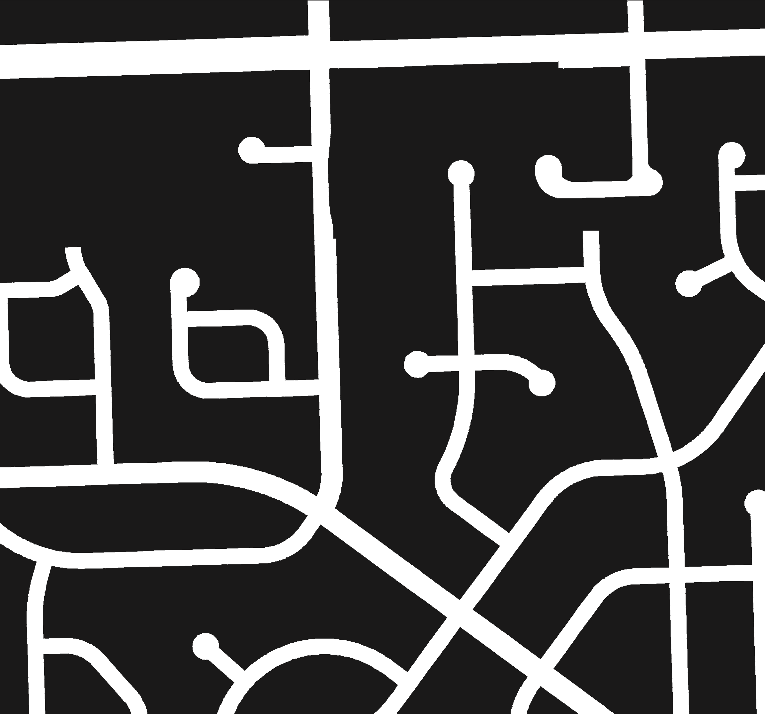
Curvilinear Pattern
Chapter 3 | Neighborhoods & Housing
33 
Lawrence Association of Neighborhoods Map
FYI- As of 2015 there are 45 neighborhoods. 15-18 are active in LAN. Some could be divided into districts.
How is Affordable Housing Defined?
? Are you defining terms below? - Affordable housing – renter - owner? How about adding definitions in this document where these words are used - Economic Development- Economic Growth- Aging in Place.
The Affordable Housing Advisory Board defines affordable housing generally as housing for which the occupants are paying no more than 30% of their income for gross housing costs, including utilities.
Renters
Housing units with monthly rent and utilities not exceeding 110% of the HUD defined Fair Market Rent, as determined yearly by the Lawrence Douglas County Housing Authority.
Owners
Could the section below be divided into 2 sections? New Neighborhoods, and Existing Neighborhoods? Existing neighborhoods would have redevelopment considerations.

Redeveloping and new neighborhoods should be designed to strengthen the unique character that people associate with Lawrence.
4. Create a safe, functional, and aesthetically unique residential environment for new and redeveloping neighborhoods in Lawrence.
- 4.1 Create a place allowing neighborhood residents to gather ensuring that future neighborhoods are unmistakably Lawrence.
- 4.2 Incorporate a mixture of housing types, styles, densities, and price ranges.
- 4.3 Design neighborhoods to a human scale, including building elements, street design, and other design elements.
- 4.4 Include vehicular and non-vehicular connections within and to surrounding neighborhoods.
- Allow for adequate off street parking as per city code
- 4.5 Incorporate safe routes to schools in neighborhood planning and design.
- 4.6 Create residential design guidelines to enhance the aesthetics of multi-dwelling development in neighborhoods.
- 4.7 Integrate small/large neighborhood commercial options into neighborhood designs.
- 4.8 Incorporate pocket parks and green spaces into new neighborhood developments.
- Provide adequate off street parking as per city code in higher density areas.
- Redevelopment must include reference to the existing Neighborhood Plan and input from neighborhood residents.
Designing neighborhoods to allow residents to age in place having access to public and health care services provides a higher quality of life and more choices.
Housing units for those earning up to 80% of Median Family Income, as established yearly by HUD for the Lawrence, KS Metropolitan Statistical Area.
5. 5.1 5.2 5.3 5.4 5.5
Create complete neighborhoods that mix compatible land uses, include varied housing types and prices, and provide services and amenities to residents of all ages.
Design neighborhoods to provide a variety of walkable live, work, learn, and play options.
Design neighborhoods to accommodate aging in place.
Create high-quality pedestrian spaces and networks connecting neighborhoods, prioritizing the pedestrian experience.
Identify and plan for service needs and resources for all residents of all ages and abilities.
Incorporate universal design into building codes. PLAN
34
Ensuring that our community has affordable and safe housing is paramount to the quality of life we all enjoy.
6. Provide affordable housing for all segments of our community.
- 6.1 Implement the policies of the Affordable Housing Advisory Board.
- 6.2 Encourage developments to account for all income ranges when creating new developments and subdivisions.
- 6.3 Promote partnerships to advance affordable and safe housing options.

Photo by A. Shafer Photography
Chapter 3 | Neighborhoods & Housing 35

