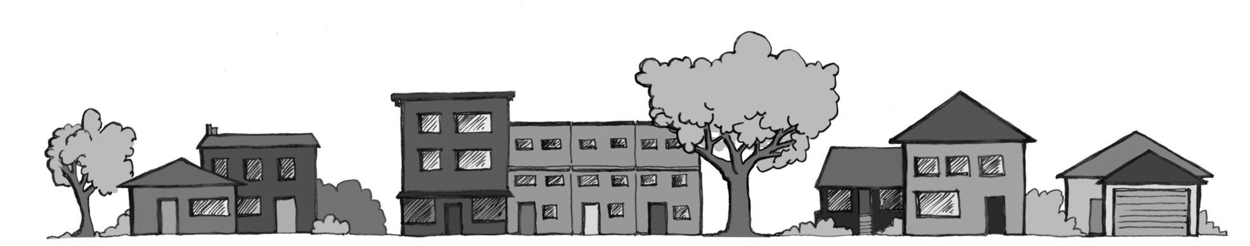
LAWRENCE ASSOCIATION OF NEIGHBORHOODS

Dear City Staff and City Commissioners, 10-12-2017

The Lawrence Association of Neighborhoods wishes to express our concern about the increase in numbers of Air B&Bs and other short-terms rentals that have no City regulations. LAN believes that this increase is impacting the stability of lower density zoned neighborhoods as well as the rental market in general. There are presently no regulations with regard to occupants, health and safety, or parking for these types of rentals. Other rentals are registered, regulated and inspected.

Issues and potential concerns:
- Non-owner occupied Air B/Bs or short-term rentals threaten affordable housing. Affordable homes then become a desirable second home investment given that one can rent the house out to any number of individuals for short periods of time and have no regulations. Affordable houses may then become less affordable due to the financial potential of such rentals.
Owner occupied Air B/B or short-term rentals might need to be a requirement in single family and low density zoned areas.

- Neighborhood stability is threatened by the constant change of occupants.
No regulations for numbers of occupants, parking, health and safety.

- “Party Houses” are becoming popular in otherwise quiet neighborhoods. Noise, trash, additional cars, crowds, and excessive drinking compromise the quality of life in neighborhoods.
Occupancy requirements are needed as per the existing neighborhood zoning.
What kind of off street parking is provided by short-term rentals?

- Health and safety are of extreme importance. All other rentals are required to be registered, meet health and safety standards and undergo regular inspections.
How can the City or neighbors contact an AirB/B or short-term owner regarding issues if they are a non-resident owner and are not listed or registered?

LAN would like to see the City implement regulations for Air B/B and short-term rental units. While modest use of this kind of rental offers possible financial assistance for homeowners, there are other individuals that will take advantage of such an unregulated use and cause neighborhoods to suffer and decline. Let’s continue to build strong, stable neighborhoods.

Thank you for your thoughtful consideration,
Courtney Shipley LAN Co-Chair, Candice Davis LAN Co-Chair

