**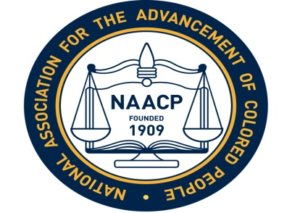  
The Lawrence Branch NAACP  
invites you to attend a  
USD 497 School Board  
Candidates Forum  
Thursday, August 10, 2017  
6:45 PM  
United Way Building  
2518 Ridge Court**

Come hear the candidates tell us their priorities  
and answer questions about  
discrepancies in student discipline,  
police in our schools,  
school board transparency,  
and more.  
**Please share this flyer. Thank you.**